|  |  |
| --- | --- |
|  | **Qatar University**  **College of Engineering**  **Department of Computer Science and Engineering** |

Senior Project Report

**IntelliCoach**

**Athlete Performance Tracking System**

**Project Group Members:**

Nirvana Aladal (201802829)

Ameena Tolfat (201802047)

Sara Alabdulla (201801904)

**Supervisor**: Dr. Abdulla Al-Ali

**2023**

This project report is submitted to the Department of Computer Science and Engineering of Qatar University in partial fulfillment of the requirements of the Senior Project course.

# Declaration

This report has not been submitted for any other degree at this or any other University. It is solely our work except where cited in the text or the Acknowledgements page. It describes work carried out by us for the capstone design project. We are aware of the university’s policy on plagiarism and the associated penalties, and we declare that this report is the product of our own work.

Student: Nirvana Aladal Date: 30 May, 2023

Signature:

Student: Amena Tolfat Date: 30 May, 2023

Signature:

Student: Sara Alabdulla Date: 30 May, 2023

Signature:

# Abstract

Sports have expanded over time, with development not only in competition but also in research. Sport studies are inextricably linked to its inherent aspects such as physical fitness, performance, and production. In this project, information on the integration of wearable devices to enhance athletic performance tracking has been gathered from subfields of research. Although there are multiple wearable technologies available on the global market to aid in sports activities, they have various limitations. Despite Qatar being one of the most forward-looking and advanced athletic nations on the globe, wearable devices are scarce in the Qatari market. Zooming in on the impediments of the existing products, one major evident setback is the lack of a communication system embedded into the wearable. Communication is crucial in sports. Coaches guide their players to ensure that they are functioning to their full capacity, which frequently necessitates immediate communication during physical activity.

Intellicoach, a low-cost, user-friendly wearable gadget designed to help coaches and athletes, will be created as part of this project. The major function of this gadget, which is designed to be worn on the chest, is to gather data on an athlete's activities and relay it to the coach, while also allowing for immediate real-time communication between the two. The device has a GPS to track the athlete's location and movement, a number of sensors working with artificial intelligence to measure heart rate and perform gait analysis, and a microphone and a speaker for real-time communication with the coach. This data is then wirelessly sent to the coach's portable through Wi-Fi. The coach may then watch an analysis of the athletes' activities while communicating with them via the handheld microphone and speaker. Due to the limitations of existing wearable sports devices, which range from high prices to a lack of necessary features, and even the fact that such devices are not available in Qatar, it is clear that Intellicoach has the potential to be adopted by the Qatari and international sports markets, as it will not only be the only wearable sports device available for an affordable price in the Qatari market, but it will also cover for the shortcomings that the existing devices have.

# Acknowledgment

We would like to express our sincerest gratitude to Dr. Abdulla Al-Ali, professor in Computer Science and Engineering Department, for initiating the necessary supervision for this project and assisting us in overcoming the tough hurdles that arose during processing and executing this report. Each member of the computer engineering department has offered us extensive professional guidance when it came to hardware implementation. We also extend our thanks to Qatar University for financing and supporting our initiative.

Table of Contents

Declaration ii

Abstract iii

Acknowledgment iv

List of tables ix

1. Introduction and Motivation 10

1.1. Problem statement 10

1.2. Project objectives 11

1.3. Project significance and expected benefits 11

1.4. Analysis of global, economic, environmental, and social impact 12

1.5. Market Research and Business Viability 12

1.5.1. Market Needs and Market Size 12

1.5.2. Target Customers and Customer Demographic 13

1.5.3. Competing Products 13

1.5.4. Price 14

1.5.5. Plan for Marketing the Product 14

1.6. Justification of the problem as a complex engineering problem 15

2. Background and related work 16

2.1. Background 16

2.1.1. Tracking systems 16

2.1.2. Heart rate and heart rate zones 17

2.1.3. Communication techniques 19

2.1.4. Motion analysis 19

2.1.5. Machine learning 20

2.2. Related work 22

2.2.1. Heart rate 22

2.2.2. Communication 24

2.2.3. Gait analysis 24

2.2.4. Complete systems 25

3. Requirements analysis 27

3.1. Functional requirements 27

3.2. Design constraints 28

3.3. Design standards 29

3.4. Professional Code of Ethics 29

3.5. Assumptions 30

4. Project Plan 31

4.1. Project milestones 31

4.2. Project timeline 31

4.3. Anticipated risks 32

5. Solution design 33

5.1. Solution overview 33

5.2. High level architecture 33

5.2.1. Module 1: Wearable Device 33

5.2.2. Module 2: Coach Tablet 34

5.3. Design alternatives 35

5.4. Hardware design 37

5.4.1. Microcontrollers 37

5.4.2. Sensors 39

5.5. Hardware/Software to be used 41

5.6. Software design 49

5.6.1. Communication 50

5.6.2. Tablet Application 51

5.6.1. Machine Learning Models 53

5.7. New-gained knowledge 55

6. Implementation 56

6.1. Hardware implementation 56

6.2. Software implementation 58

6.2.1. Communication 58

6.2.2. GUI implementation 60

6.2.3. Machine Learning 63

6.3. New-gained knowledge 65

7. Testing and Evaluation 66

7.1. IC Device 66

7.1.1. Sensors 66

7.1.2. Batteries 68

7.1.3. Communication 69

7.2. Tablet 69

7.2.1. Communication 69

7.2.2. UI response 70

7.3. Evaluation 75

8. Analysis of the impact of the engineered solution 77

9. Conclusion 78

10. Future work 78

11. Student reflections 79

References 81

Appendix A – Culmination of Design Experiences 85

Appendix B - Project Plan 86

B.1. Gantt Chart for SDP 1 86

B.2. Gantt Chart for SDP 2 86

Appendix C – Meeting Minutes 87

Appendix D – Software Implementation 87

**List of figures**

Figure 1. Navstar GPS Satellite 17

Figure 2. Confusion matrix 21

Figure 3. Classification of the apps in the commercial review 23

Figure 4. High-level Architecture 35

Figure 5. Schematic Diagram of IntelliCoach Connection 45

Figure 6. Breadboard diagram of IntelliCoach Connection 46

Figure 7. IntelliCoach PCB design 46

Figure 8. IntelliCoach initial device case design 47

Figure 9. IntelliCoach modified device case design. 47

Figure 10. Front side of the case 3D design 48

Figure 11. Back side of the case 3D design 48

Figure 12. Integrated IntelliCoach device prototype 48

Figure 13. System overview 49

Figure 14. communication overview 50

Figure 15. IntelliCoach GUI interface 51

Figure 16. Heart rate zone flowchart 52

Figure 17. ML Accuracy 53

Figure 18. Confusion Matrix 54

Figure 19. Embedded connections 57

Figure 20. Front side of IC device 57

Figure 21. Back side of the IC device 57

Figure 22. Libraries used 59

Figure 23. GUI implementation 61

Figure 24. Dialog to ask user to enter their name 62

Figure 25. Dialog to ask user to enter their age 62

Figure 26. Predicted activity 64

Figure 27. Meeting minutes 87

# List of tables

Table 1. Expected benefits and impacts of various contexts. 12

Table 2. Competing products 13

Table 3. HR Zones 18

Table 4. Related works in comparison with IntelliCoach 26

Table 5. Functional Requirements 27

Table 6. Design Constraints 28

Table 7.Engineering Standards used in the project 29

Table 8. Engineering Code of Ethics and Professional Practice 29

Table 9. Milestone of the project 31

Table 10. Milestones of the project 31

Table 11. Risks 32

Table 12. IntelliCoach and Smartphone Comparison table 36

Table 13. Small microcontroller 37

Table 14. Normal microcontrollers 38

Table 15. GPS 39

Table 16. Heart rate sensors 40

Table 17. Gyroscope & Accelerometer 41

Table 18. HW/SW needed 41

Table 19. Testing the readings of the heart rate from MAX30102 66

Table 20. Testing the readings from MPU6050 67

Table 21. Testing the GPS's provided coordinates 67

Table 22. Testing that the battery is supplying the whole circuit with power 68

Table 23. Testing the Built‐in Wi‐Fi Module 69

Table 24. Communication test between Wi-Fi and HUAWEI tablet 69

Table 25. Sending sensors data test 70

Table 26. Application test 71

Table 27. Machine learning test 71

Table 28. Map test 72

Table 29. Chart test 73

Table 30. Speaker integration test 73

Table 31. Battery life test 74

Table 32. Technical and practical design constraints evaluation 75

Table 33. Functional requirements evaluation 76

Table 34. Expected benefits and impacts of various contexts 77

Table 35. Wireless connection code 87

Table 36. Sensors Data code 89

Table 37. Send and receive data code 90

Table 38. Gui implementation code 91

# Introduction and Motivation

Sports have played an increasingly crucial part in nation building in many countries around the world over the last few decades. Qatar, for example, views sports to be a key pillar of its national 2030 vision, with the goal of becoming a worldwide leader in sports and attaining relevance through sports growth. Furthermore, in keeping with its objectives, the country has a world-class sports medicine hospital, Aspetar. Aspetar's objective is to help athletes achieve their peak performance and potential.

Athletes are more likely to have erratic workout routines, which might be detrimental to their health. Therefore, it is crucial to preserve and keep an eye on their health not only at Aspetar but also throughout competitions. Miscommunication between the coach and the athlete is one of the primary issues during training. Even though there are devices that can offer the essential information while monitoring players, many lack several important features. In fact, no wearable gadget has a technology that supports communication services on the Qatari market. As a result, a useful tool to support this is required. The device should be portable, lightweight, and simple for the players to operate in order to assist the coach in directing the players while collecting vital data about them. The athletes will be allowed to play on the field as their coaches monitor them in a systematic manner remotely.

## Problem statement

Despite the market availability of sports wearables, many have disadvantages such as lack of essential functions, bad designs, insufficient accuracy, and expensive pricing. This project seeks to give new features to execute a design with all of the essential elements in it one place, as well as real-time and offline communication strategies that account for the distance between players and coaches during physical activities. Among the challenges that could arise are the following:

Non-technical:

* Designing a device that is portable, lightweight, and comfortable for the player
* Offering an affordable high-quality device

Technical:

* Providing real-time wireless communication between the player’s device and the coach’s tablet
* Designing a lightweight device with a reasonable battery life using WI-FI communication
* implementing machine learning for analyzing players' motion in real time

## Project objectives

The following is a list of the project's main objectives:

1. To design and develop a wearable device to track the movement and monitor the health of athletes that integrates accelerometer and gyroscope sensors along with a heart rate sensor.
2. To provide real-time and offline athlete performance analysis to coaches
3. Ability to communicate over distances between the coach and team members through speaker.
4. Classify athletes’ movement based on machine learning models from sensors such as the gyroscope and the accelerometer.

## Project significance and expected benefits

Consider today's world without technology-enabled communication; all aspects of daily life would be more difficult. With the mere press of a button, technology has enabled us to talk even if we reside on separate continents, and such simplicity should be the case.

Sports are an area where, in order to be successful and at the top, one must perfect one's performance, which can only be accomplished with strong fitness levels. Wearable gadgets may be extremely beneficial to athletes since they can assist monitor activity and collect data to create a picture of what an athlete has done during a training session. However, merely having a summary of what is done is insufficient; for optimization, the coach's contribution is critical, particularly during training. Effective athlete-coach communication is the best method to do this, and communication via wearables would enable this.

Hence, our proposition is to design and develop a wearable, that integrates an accelerometer, gyroscope sensors and a heart-rate sensor, for monitoring the health of the athletes through gait analysis, tracking and classifying their movement using machine learning models that will be obtained from the sensors. Along with this, the coaches will also receive real-time performance analysis of the athletes wirelessly on handheld tablets, while being able to have immediate communication with them during training sessions.

Communication in sports has always proven to be vital, particularly between coaches and athletes, since it is crucial to optimize athlete performance through athletic advancement in addition to creating athlete-coach relationships. Research was conducted on teams utilizing verbal and nonverbal methods of communication, and the team that used verbal method of communication obtained higher coordination [1].

The key target market for this is Qatar and gulf region, a country that has placed a strong focus on sports development and continues to do so, hosted the world's largest athletic event, the FIFA World Cup. Despite its size, the Qatari market now lacks access to sports wearables. Furthermore, despite their unavailability, these wearables are in great demand in the Qatari market based on a meeting with Al-Gharafa team trainer coach Mohammed for full references, see Appendix C. As a result of our Qatari market analysis in terms of supply and demand, the launch of Intellicoach into the market has the potential to be adopted not only by sports equipment outlets for general use, but also by professional teams and athletic institutions.

Furthermore, this project contributes to human capacity building by introducing technologies that will play a significant role in the country's development and opens doors for local institutions to compete on manufacturing gadgets and adopting ideas, particularly from Qatar university students and other local universities that can participate in enhancing technology and education to a higher level.

## Analysis of global, economic, environmental, and social impact

Table 1. Expected benefits and impacts of various contexts.

|  |  |
| --- | --- |
| Context | Expected benefits and impacts |
| Global | This project addresses human well-being and aids in enhancing athletic performance by promoting healthy physical activity, through provision of results depicting the monitored heart rate and workout patterns. |
| Economic | This project raises the knowledge around sports. As a result, Qatar economy will thrive by developing the local market by providing sporting goods. |
| Environmental | The use of rechargeable lithium batteries will eliminate hazardous waste, if they are correctly disposed for recycling. Furthermore, the use of plastic filament casing makes this project ecofriendly. |
| Societal | The production cost of the product is low, making it more accessible to people due to its affordability. |

## Market Research and Business Viability

### Market Needs and Market Size

For the previous decade, the Qatari government has encouraged the expansion of sporting activities as sports play a significant role in the Qatar National Vision 2030. Every February, a national sports day is designated as a public holiday. Qatar has a longstanding experience of producing athletes, engaging in world-class training centers encompassing all age groups and personal backgrounds and organizing international sporting events including the Amiri Cup, the 2006 Asian Games, the World Handball Championship 2015, and the upcoming FIFA 2022 World Cup [30]. Aspire Academy, a national leader in fitness and sports science expertise, technology, and research, is one of the training facilities that focuses on using wearable devices to monitor the health of the athletes [31]. Athletic facilities, clinics, rehabilitation centers, and other health-care facilities are all seeking to deliver cutting-edge devices and technologies oriented on physical wellness. Revenue in the Digital Fitness & Well-Being category in Qatar is estimated to reach US$34.28 million in 2022, with an annual growth rate (CAGR 2022-2027) of 12.56%, culminating in a market volume of US$61.94 million by 2027 [32]. The most prevalent purposes of modern wearable devices are performance enhancement, training optimization, injury prevention, stress factor calculations, and ways for assessing experience level. Our technology is an excellent candidate for this market since it serves the purpose and adds a new perspective to physical health evaluation and diagnosis.

### 1.5.2. Target Customers and Customer Demographic

The primary target market for this project is sports clubs. The innovative use of smart wearable IoT devices may effectively satisfy the demands of various local businesses due to the constant development of new products and technological advancements. The IC wearable device utilized for this project has been developed specifically for athletes to wear and to provide coaches with the ability to effectively monitor and track their performance. We aim to serve sports clubs that place a high priority on implementing innovative technologies in order to protect the health and safety of their teams. Qatar Sports Investments takes an active role in engaging in sports endeavors, both domestically and internationally. Their notable investments include renowned teams such as Paris Saint-Germain Football Club, FC Barcelona, Al-Arabi Sports Club, and Qatar Sports Club [33], among other prominent sports ventures. These investments play a vital role in promoting the development and utilization of sports facilities in Qatar. As part of our commitment to supporting athletes of all ages and genders in their pursuit of enhanced performance, we have developed a cutting-edge wearable device. This device offers comprehensive activity tracking and is designed to assist athletes in their journey towards athletic improvement.

### 1.5.3. Competing Products

Table 2. Competing products

|  |  |  |  |  |
| --- | --- | --- | --- | --- |
| Product Reference | Product | Features | Cost | Country of Origin |
| [34] | Polar Team Pro by Polar | Athlete monitoring system that measures heart rate, speed zones, and acceleration using high accuracy GPS-derived movement detection. Designed to seem like a band around the chest and connected to a tablet device application. | Various packages exist and starting price is from $7,500 for a package | Finland |
| [35] | Apex Athlete Series by Stat Sports | GPS tracker that detects distance, speed, strain, intensity, acceleration, heart rate, and calories. Designed to look like a cropped top and connected to a phone application. | $299.99 | Ireland |
| [36] | McLloyd STv4 Performance Tracking System | Tracking system for coaches that measures the performance through distance, speed, acceleration, steps, heart rate, energy, and impacts. Designed to look like a cropped top and connected to a desktop application. | $349.99 /month | France |
| [37] | Suunto Smart Heart Rate Belt | Multisport belt that provides heart rate measurement only. Designed to seem like a band around the chest and connected to a phone application. | $79 | Finland |
| [38] | The Catapult PLAYR SmartCoach System | Coaching system that provides sport specific insights and has an integrated heart rate sensor. Designed to look like a cropped top and connected to a phone, desktop and iPad application. | $199.99 | Australia |

### 

### 1.5.4. Price

The cost of each component utilized to implement our device is listed in the hardware design section 5.5. Based on the total of the component prices and shipment expenses, the price per gadget is 650 QAR. In comparison to the price ranges in table [2] of our competitors' products, our gadget is relatively reasonable when considering the additional features it provides. Given that the gadget is designed to be worn by a team up to 11 players based on our design constraints in table [4], the package cost will be roughly 7,150 QAR per team. In the future, we can add subscriptions in our offerings to provide our customers a range of options with variable pricing.

### 1.5.5. Plan for Marketing the Product

Our marketing strategy will be carried out in two major methods, both of which will be implemented concurrently. The first plan will consist of organized health awareness campaigns. Furthermore, the campaigns can take place in various athletic clubs across the country. We will have the opportunity of advertising our product and testing it on athletes during the period of sport events that Qatar hosts including FIFA world cup and Sports Day. Because Intelligent Coach is a local device, we will have an advantage over competitors. The other method will be to seek out local investors to purchase our prototype at a reduced cost. This strategy will assist us in better understanding the features that consumers demand and will improve customer service. Furthermore, it will aid in doing a SWOT analysis (strength, weakness, opportunities, and threats) to rely on our strengths, use them as an advantage, and be aware of any product shortcomings. Once the prototype is completed, more analysis can be performed.

## Justification of the problem as a complex engineering problem

The issue arises in providing a tracker with a decent battery life that enables athletes to complete at least one entire training session while still having an appropriate range of connections.

The local customizability is given high emphasis in various elements of this design, such as aspire zone. As a result, we intend to propose a device that offers a reasonable bandwidth and acceptable battery life at a fair price in order to balance these competing concerns regarding the discomfort of the design, battery life, and reasonable bandwidth coverage for connection. The costs of the project product and the competitor product are shown in sections 6.3 and 6.4, respectively, and section 4.3 displays the HW/SW that was selected to provide a high level of data collection with consideration to conflicting requirements. As for communication, Wi-Fi protocol will be used to establish the connection between gadgets using UPD packets.

* **Interfacing**

The wearable gadget and the coach tablet are the two main modules of the high-level architecture, which is depicted in section 4.2. Each module has a unique system that needs to be connected via a communication system in between. In its simplest form, the wearable device is a tracker. At this stage, the tracker consists of four sensors, including the MAX30102 Heart Rate Pulse Detection, MPU6050 (gyroscope and accelerometer), Arduino nano 33 IoT (microcontroller), and Adafruit ultimate GPS. The microcontroller is linked to the three sensors, forming a system that is in charge of reading the athlete data and forwarding it to the coach tablet. The coach tablet runs an Android operating system and will be connected through Wi-Fi to get the data. The information obtained from the sensors embedded within the tracker will be sent to the tablet and displayed by an application. On the other side, the application will give the coach a complete view of all athletes, including their readings.

For this system, Arduino IDE will be used to assist in running a software program that can offer all the necessities needed to develop a whole operating system that includes both hardware and software designs and the complexity lie in merging the two systems together. Designing such a system necessitates extensive engineering operations to properly combine the hardware with the strap in order to make the solution pleasant for the athlete. In contrast to building software with an accessible and user-friendly user interface to permit bidirectional contact with individual athletes.

* **Cross-disciplines**

However, tracking can be used in a variety of disciplines that are not always associated with athletic fields. The tracker has applications in the military and in fields like medicine. The heart rate sensor on the trackers can be monitored medically. Locating opponents, for example, is crucial from a military standpoint. The design of the system must, to some extent, be integrated when it comes to employing the trackers and incorporating them into various disciplines in order to meet the targeted feature requirement. The design can also be utilized by people who are not athletic but want to keep track of their workouts; it doesn’t need be aimed at an entire team of players necessarily. As a result, the nature of design can be applied outside the project's primary discipline.

* **Trade-offs**

The two technological difficulties that were encountered throughout the project's creation had to do with the battery life and the Wi-Fi bandwidth in relation to the distance that it could travel while still maintaining the connection between the coach and the player. The design will make use of a lithium coin battery that can be recharged and can run for at least 1.5 hours to resolve the battery life issue. In terms of bandwidth and connectivity, the Wi-Fi bridge feature in the HUAWEI MatePro Pad will allow the tablet to act as an access point to all the devices.

Additionally, by including a speaker that enables the coach to verbally converse with the player during the training session, the design will address the communication issue that all trackers now on the market lack.

# Background and related work

## Background

The key concepts and ideas that will be mentioned in relation to the project will be covered in this section.

### Tracking systems

Tracking systems are often used to monitor an object's position, movement, or any other attributes according to the desired tracking system. Numerous tracking systems utilize various techniques and algorithms to accomplish various goals. Thus, in terms of the project, the global positioning system (GPS) is very crucial tracking system that will meet the project's needs.

The global positioning system (GPS) offers accurate positioning and timing data in any location and regardless of the weather. GPS is a one-way-ranging system for security purposes as well as serving an infinite number of users. Users are limited to receiving satellite signals [3].

Technology has evolved over time to enhance people's lives in a variety of ways, including sports. There are several types of tracking devices with various objectives, but they all have the capability of monitoring and placing objects. The first tracking system, specifically the Global Positioning System (GPS), was invented in 1978 by the United States; it included 24 satellites and became fully operational in 1993; historically, GPS was invented for military purposes, but GPS now has multiple applications; NAVSTAR is the first GPS satellite launched into space by the Americans [4]. The GPS system evolved and began to be used in mobile phones and other electronic devices for a variety of reasons.

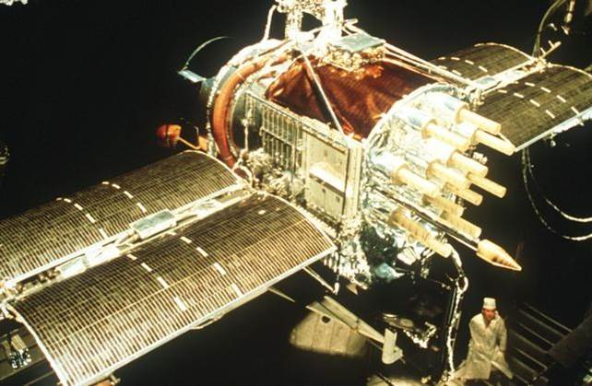

Figure 1. Navstar GPS Satellite

The basic concept behind GPS satellite is that it uses techniques that helps in finding the position of an object by calculating known coordinates such as longitude and latitude [5]. On the other hand, the transmitted signal from the satellite can be received by any possible electronical receiver. For instance, mobile phones, computes, Garmin’s or by a GPS sensor that contain antennas that receive the signals that are delivered from the GPS satellite and use them to provide position, velocity, and timing data. The GPS sensors can be embedded within any device nowadays to serve different kinds of technical purposes in different aspects.

### Heart rate and heart rate zones

Medically, heart rate (HR) is defined as the number of heartbeats that occur in a specific amount of time, usually one minute. There are devices that monitors heart rate for medical purposes. However, they can be used in different aspects. In relation to the project, heart rate can be useful for athletes and coaches to help monitor their health. The heartbeats can be monitored using two types of heart rate sensors. The types of heart rate sensors such as electrical and optical are mentioned below.

Cardiologists frequently employ ECG sensors to diagnose patients and look for any signs of disease [7]. The ECG analysis and exchange are used by the electrical heart rate sensors. A fundamental set of algorithms that condition the signal with respect to different types of noise and artifacts, detect heartbeats, extract basic ECG measurements of wave amplitudes and time duration, and compress the data for efficient storage or transmission are shared by all types of ECG analysis, whether it concerns resting ECG interpretation, stress testing, ambulatory monitoring, or intensive care monitoring [8]. ECG heart rate sensors capture electrical signals in the blood and store the data that has been collected.

Optical heart rate sensors employ the photoplethysmography technique (PPG). In wearable medical technology, it is frequently employed. PPG is a non-invasive electro-optical technique that provides data on the amount of blood flowing through a body testing zone near the skin. For the purpose of acquiring PPG signal, a light source with a wavelength of which is λ is put on one side of a body part (for example, a finger), and on the opposite side, a photo-detector is positioned directly across the source to detect the transmitted light. A typical PPG signal consists of the following components: a large DC component that passes through skin, muscle, and bone without passing through blood vessels; a small AC component that separates from the skin, muscle, and bone and passes through the blood vessels; and a light component that passes through the arterial blood vessels. The volume of blood in the arteries increases shortly after the systole, which causes the amount of light received to reduce. The volume of blood in the arteries decreases during diastole, and an increase in light transmittance could be seen. On a standard measurement zone, 99% of the signal originates from the skin, muscle, and bone, whereas 0.9% and 0.1%, respectively, come from veins and arteries [9].

To determine what heart rate zone, they are in with the help of using heart rate sensors. Heart rate zones indicate your optimum heart rate as a percentage. The maximum HR can also be calculated through equations, each gender has a different equation [10]:

For females:

${HR}_{max}=208.3-0.74×age$ (1)

For males:

$${HR}_{max}=207.5-0.78×age (2)$$

For athletes (both genders):

${HR}_{athletes}=208.5-0.8×age$ (3)

In general, there are 5 zones that represent the maximum heart rate of an athlete although each athlete has a different zone based on the measurement of their HR each zone targets a percentage of the HR. The zones, target and duration are shown in table 2 below.

Table 3. HR Zones

|  |  |  |
| --- | --- | --- |
| Zones | Target HR | Duration |
| 1 | 50% to 60% | All day |
| 2 | 60% to 70% | 1 hr. or more |
| 3 | 70% to 80% | 10 to 60 min |
| 4 | 80% to 90% | Up to 10 min |
| 5 | 90% to 100% | Up to 40 sec |

### Communication techniques

In any sports training sessions, communication is a significant step between the coach and the players. More communication between them will enhance their performance during the match or training. As for the communication during the training sessions coaches communicate with player by shouting or using electric megaphones speakers to give them instructions on what to do. New methods have been introduced, such as Wi-Fi and Bluetooth through embedded speakers to establish clear communication. These methods will ease the way of communication.

Wi-Fi has a bandwidth limitation which means that the sound can be affected by noise when the athlete and coach is not within the bandwidth range. Also, WiFi has high power consumption which can affect the battery life of the device. As for Bluetooth it has a lower power consumption than the Wi-Fi especially in the Bluetooth Low Energy (BLE). There are 3 main structures that can be built on the BLE; the star network, the mesh, and the tree structure network. The star network is the simplest topology, it consists of 1 central node and several peripheral nodes. Although it is the simplest network, the number of nodes that can be connected to the central node is limited. The mesh topology, each device in the networks is linked to a few or all the other devices. Mesh is made of 1 coordinator and several routers and devices. Mesh topology has a high fault tolerance ability. However, it is considered a complex network protocol. As for the tree structure network. It consists of one grandpa node, parent's nodes, and children's nodes in a hierarchical way. The tree structure topology is simpler than the mesh, and it is larger in coverage than the star network [11].

Bluetooth is being used in many applications because of its adaptive nature where it can be used with many devices. For instance, Bluetooth is used to connect mobile phones and any Bluetooth compatible car stereo system, speakers, or headsets [12]. Moreover, Wi-Fi is being used in our daily life to connect with others using our mobile phones, gives us access to the internet, and smart watches. Since Wi-Fi and Bluetooth have been introduced in many communication applications, then they can be used in such setting to ease the communication between the coach and players. The easier the communication is, the more effective during the match time.

### Motion analysis

The systematic study of human movement is known as gait analysis. This sort of study entails measuring, analyzing, and evaluating parameters that describe human movement [13]. The gait stage may be detected, and the kinetic properties of human gait events can be calculated via gait analysis. It has consequently been used in sports, rehabilitation, and health diagnoses. We review the available literature to investigate the offered solutions for improving gait analysis approaches. It is hard for the human eye to detect the exact body movements because it requires to know the exact muscles and movements [14]. To analyze the motion of the players, there have to be motion detectors and sensors to record the motion of each player. Gyroscope and accelerometer are examples for these motion sensors, where a gyroscope measures the orientation, and the accelerometer measures the acceleration of the object. Gyroscope is a term that derives from the Ancient Greek language, which refers to the “precession motion.” It is built in a way such that there is a rotating frame, and it has the ability to sense the angular velocity of the body. There are many classes of gyroscopes, such as mechanical, optical, micro-electromechanical system gyroscopes. Moreover, gyroscopes can either be used alone or incorporated in more complex systems. For example, Gyrocompass, Inertial Measurement Unit, and Inertial Navigation System. Hence, gyroscope is being used in many systems and has multiple applications and using better instruments with improved accuracy will bring higher cost of the system [15]. Also, accelerometer is being used widely for gait recognition. For example, it is being used in phones to recognize when the mobile phone is rotating and finds the acceleration depending on some readings. It measures the acceleration in three axes/directions (x, y, and z). Data of the accelerometer can be derived from multiple equipment, such as a GPS Device, dedicated accelerometer, mobile phone. Moreover, data can be analyzed in either time or frequency domain. To analyze the data in time-domain, the directions (X, Y, Z) are measured over time (t). However, in frequency-domain, for each frequencies, a frequency band is given [16]. Therefore, we will use these sensors to help us detect the motion. Data collected from these sensors then will be used to provide a description of the gait analysis. Linking data to the gait analysis requires Machine Learning, which will be discussed in the upcoming section.

### Machine learning

With the technological advancements of the previous several decades, it is now feasible to collect massive amount of data from athletes. Wearable gadgets, tracking systems and video analysis systems are few types of data collection equipment utilized in sports nowadays. The data collected may be used for data analysis, observation, and performance monitoring through generating complex models. Through the use of Machine learning, we can analyze data thoroughly, assisting coaches and scientists better understand the elements that influence both team and individual performance. Machine learning is a burgeoning domain of computational algorithms that aim to replicate human intelligence by learning from their surroundings. The primary goal is to develop intelligent, functional computer models capable of solving complex problems and generating predictions focused mostly on computational and analytical theories.

Traditional machine learning techniques are classified into three major categories: supervised, unsupervised, and reinforcement learning. Supervised learning techniques attempt to model connections and dependencies between the intended prediction output and the input characteristics so that we may anticipate the expected output for new data depending on those correlations learnt from prior data sets. Unsupervised learning, on the other hand, occurs when the result is unknown, and predicting the outcome is accomplished by examining patterns in unlabeled input data. Reinforcement learning enables machines and software agents to dynamically select the appropriate behavior in a given circumstance in order to optimize their performance.

Supervised machine learning methods including naive bayes, decision trees, linear regression, and neural networks are used in sports analytics. Unsupervised machine learning approaches for regression and classification, such as k-means clustering and association rules, are also employed in sports analytics. These algorithms analyze sports data from a variety of sources to provide helpful insights about player performance and team efficiency.

A confusion matrix is a table structure that displays the multiple outcomes of a classification problem's prediction and aids in visualizing its results.

Figure 2. Confusion matrix

Evaluation metrics may be used to analyze the performance of a model, monitor the ML system in practice, and regulate the model. Accuracy, precision, recall and F1 are the basic measures utilized to examine a classification model. The ratio of correct predictions for the test data is termed as accuracy. This metric is defined as the percentage of correctly classified cases to total number of classified cases [17].

$Accuracy=\frac{Number of Correctly Classified Examples}{Total Number of Cases }$ (4)

Because the accuracy rate does not consider for class distribution, some classes may contain less data points than others in the same model. As a result, alternative metrics like as accuracy, recall, and F1 are applied. Precision is described as the proportion of specific examples (true positives) among all examples projected to belong to a particular class.

$Precision=\frac{True Positives}{True Positives+False Positives}$ (5)

The amount of correct positive predictions made out of all potential positive predictions is tracked by recall. In contrast to accuracy, which only considers the most accurate positive predictions out of all positive predictions, recall considers all positive predictions that were missed.

$Recall= \frac{True Positives}{True Positives+False Negatives}$ (6)

The F1 score is a number that strikes a balance between recall and accuracy by calculating the harmonic mean of the two.

$F1=2\frac{Precision x Recall}{Precision+Recall}$ (7)

## Related work

Numerous studies have been conducted on wearable trackers that are aimed at athletes to examine their capabilities and how the technology employed in the devices can help to improve performance.

### Heart rate

Important biological parameters of stability, heart rate (HR) and heart rate variability (HRV) might serve as early indicators of some abnormal diseases. Ambulatory monitoring of HR and HRV has been possible thanks to technological advancements, first in the medical sector and more recently with consumer applications in the general population. The development and application of wearable technology has been significantly influenced by cardiovascular medicine, particularly cardiac electrophysiology [18]. Heart rate variability (HRV) is a term used to describe the variation in the time between adjacent heartbeats. The fluctuation in beat-to-beat interval, which is measured in milliseconds, can change depending on a number of variables.

The foundation of PPG is the measurement of variations in microvascular blood volumes. A photodetector receives reflected photons from an emitter that sends pulses of light that travel through the skin and counts their varying intensities, which can be converted into a recording of a tachogram. Simple PPG-based sensors might be sufficient for heart rate detection, but since HRV measurements are not necessary for this phase, there is a lack of validation. Consumer-grade equipment that uses PPG has a strong accuracy correlation with ECG readings. PPG-based medical grade devices are more accurate. PPG is most effective when there is good skin-to-device contact, which can be difficult to achieve when using watch and wristband straps, especially during physical exercise. It has also been observed that dampness, tattoos, and skin tone can influence PPG accuracy. The underestimate of heart rate (HR) in arrhythmias, particularly atrial fibrillation, when early contractions produce a weaker pulse that may not be recognized, is a key drawback of PPG-based heart rate assessment. Although PPG-based devices have a lot of advantages in terms of accuracy and usability, they nonetheless have drawbacks [19].

PPG-based devices measure the quantity of blood flowing through the wrist using green and infrared LED lights and photodiodes. Variations occurring during the cardiac cycle are used to detect each systolic event and subsequently to determine the heart rate at sample frequencies in the 0.1–1 kHz range. A range of 30-210 bpm is supported by the optical sensor. In addition, the sensor may boost sampling rate and LED brightness to make up for low signal levels. In order to calculate walking average and HRV during workouts or "breathe sessions," the green LED uses a higher sampling rate than the infrared sensor, which is utilized for background/baseline data and heart rate notifications [20].

Owners of smartphones are continuously rising. Smartphones are useful for usage in the medical field because of their accessibility, portability, user-friendliness, affordability, wireless connectivity, powerful computational power, and sufficient memory [21]. There are 710 relevant apps for cardiology available in commercial stores, some of which are available in both the App Store and Google Play. A classification of the apps in the commercial assessment by target users is shown in Figure 3.

Figure 3. Classification of the apps in the commercial review

The study focuses on mobile systems for monitoring the heart and other vital indicators as well as how to classify cardiac indications to look for irregular activity. Blood pressure monitoring, systems for the identification of heart failure, and mobile cardiac rehabilitation systems are other systems with a sizable number of papers. Heart monitors and medical calculators make up the majority of cardiology apps [22].

The Heart Rate Monitoring system [23] was created with the use of IOT technology with the aim of sensing the patient's heartbeat in order to track both the regular checkups and the risk of a heart attack. IoT is particularly helpful in this regard because it provides crucial information and replaces the traditional monitoring methods with a more effective approach. For data collecting, this device makes use of a heart pulse sensor. The microcontroller processes the data signals from a human heartbeat. The IoT platform receives the processed data and uses it for additional analytics and visualization.

### Communication

Enhancing the work environment and affording a safe environment for the people has always been worked on. Communication methods have been used to solve many issues in different aspects, such as, healthcare systems, military, and sports. For example, in healthcare systems, real-time health monitoring systems that record the patient’s health parameters are being used. In [24], it is proposed to enhance the healthcare monitoring system by improving the communication of data by using different modes; Bluetooth Low Energy (BLE using a mobile application), messaging services, and Wi-Fi. The system proposed is between patients and clinicians, where the patients have to wear small wearable sensors, and the clinicians will have to read the patients’ data and access them through a tablet or a smart device that can present the data in real-time. Also, the clinicians get notified through GSM and receive an SMS message if there is anything important to know at any moment. Therefore, there are multiple modes proposed for the system to make the most out of it and monitor the patients in real-time and notify the clinicians when needed.

Moreover, in military services, to ensure the safety of the soldiers on the battlefield, there have been proposals to enable monitoring the military applications. The proposal in [25] consists of two parts; the portable remote soldier unit and the monitoring center. The proposal aims to monitor the soldiers in real-time using GPS networks to locate their location and keep a record of the bio-signals of them. The soldier unit has two sensors; the temperature sensor and the heartbeat sensor to read and convert these readings into digital signals and compare them to the actual signals. If any differences are found between the values, then it is considered as an emergency. Therefore, this shows the use of Wi-Fi in order to monitor the soldiers in battlefield, as this can be further implemented to solve other problems and enhance others.

In addition, energy consumption is a key topic to be considered in communication projects. Paper [27] showed that 3G communication is the largest consumer of energy, followed by Wi-Fi and Bluetooth communication. Wi-Fi has been found to be 40% more energy efficient when compared to 3G communication. Therefore, even though Wi-Fi consumes energy, it is still more energy saving than 3G communication. Therefore, different communication methods have been used to enhance many aspects in our real-life so that it makes it easier and safer for the individuals related to the issue.

### Gait analysis

There are several studies that utilize wearable sensors and gait analysis to quantify human mobility. Chung et al. [13] investigated a wearable gait analysis device comprised of a triaxial accelerometer to study a stride identification algorithm to assess gait information for individuals with Alzheimer disease. The gait analysis experiment included nine Alzheimer's disease patients and three healthy controls to validate the design's efficacy. The stride detection algorithm, which consists of data collecting, signal preprocessing, and stride identification techniques, was created to get gait feature information from acceleration signals. According to the results of the experiments, the AD patients had a considerably shorter mean stride length and a slower mean gait speed than the healthy controls. They have concluded that the suggested wearable gait analysis device is a viable tool for automatically evaluating gait data, which can serve as early detection indications.

‌ Lianzhen and Hua [28] investigate the standard rehabilitation assessment technique and present an athlete rehabilitation evaluation system that combines Internet of Things technology with a human gait analysis algorithm. It presents a multiscale stair gait planning algorithm based on dynamic motion primitives, builds the overall structural framework of the system model based on real demands, and fully utilizes the Internet of Health Things system's advantages to optimize system performance.

Through analyzing the measurement results of the gyroscope and the integrated accelerometer, the literature [29] assessed and confirmed the usefulness of the integrated accelerometer to measure dynamic acceleration. A combination of sensors like gyroscopes and accelerometers can also be utilized in the measurement and investigation of human gait to gather additional human kinematics data. By placing it on the foot, calf, thigh, and other areas, angle adjustments of essential portions such as the ankle joint and knee joint may be accomplished. Furthermore, wearable sensors for human gait analysis may be made from flexible goniometers, ETS, and sensing textiles.

The literature [30] outlined the accelerometer measuring method used based on different measurement tasks and applied triaxial accelerometry system to examine the motion characteristics of 133 healthy male soccer participants in a 30-second walking test. The data collected were evaluated using the gait evaluation differential entropy method (GEDEM). This method may provide information to trainers and clinicians about an athlete's musculoskeletal condition's gait stability.

In order to ensure the validation of kinematic-based algorithm used for evaluations of treatments for pathological gaits, the literature [31] proposed a gait detection method to compare and validate a kinematic-based algorithm used in the detection of four gait events, heel contact, heel rise, toe contact and toe off. The data were used to determine the gait events using three methods: force, visual inspection and algorithm methods. The algorithm method provided the duration of three intervals, heel contact to toe contact, toe contact to heel rise and heel rise to toe off, which are not readily available from force platform data. The ability to automatically and reliably detect the timings of these four gait events and three intervals using kinematic data alone is an asset to clinical gait analysis.

### Complete systems

##### **Polar**

GPS-based athlete tracking system by polar is one of the products that has been available in the market. It's designed for professional sports teams, it includes GPS-derived movement data, heart rate monitoring, speed, and acceleration. The device can be connected to a tablet and designed as a band over the chest. The GPS shows a high accuracy in movement tracking based on a study that used the GPS by polar [32].

##### **Stat Sports**

Another available device is the Apex Athlete Series by Stat Sports. It includes 16 key metrics, and it mainly calculates the total distance, sprints, and heart rate maps. The design of the product is a cropped top like, it is connected to a mobile app for personal use only. In addition, a study has shown that Apex trackers show higher accuracy than other wearable trackers and watches [33].

##### **McLloyd**

Another product that has been introduced on the market is the McLloyd STv4 performance tracking system. It is a real time GPS tracking system, used for sports teams. It includes distance and speed, acceleration, jumps and steps, heart rate, energy, and live mapping. The design of the product is cropped top like as well. As for accuracy, in terms of Distance: 1% Position: 1,5m, Speed: 0.05m/s, Acceleration: 0.2m/s2, IMU: 0.01g / 0.5deg/ 0.02deg/s [34].

##### **Suunto**

The fourth product that is available on the market is Suunto Smart Heart Rate Belt. It is used for multiple types of sports. The features included in the product are water resistance, and can undergo water until 30 m, measures heart rate and heart rate variability measurements. The design is a chest strap. And it is for personal use using a mobile application [42].

##### **Catapult**

The last device that has been researched is the Catapult Playr Smart Coach System, the device is able to optimize the performance for athletes, detect injury risks. It includes clearsky technology which means that it uses advanced local positioning system (LPS) that can deliver pinpoint positional and inertial data in any environment, and it integrates the heart rate of athletes. It has a cropped top like design too [43].

The price ranges of the listed devices above are between 79$ and 349.99$, the price of each device is mentioned in table 14. Section 6.3.

In contrast to what was stated above, the project will have speakers, a GPS, an accelerometer, and a heart rate sensor. The GPS calculates the distance and maps the athletes, the heart rate sensor measures each player's heart rate, the gyroscope and accelerometer are used for ML in gait analysis, and the speakers enable spoken communication between athletes and coaches. The gyroscope, accelerometer, and speakers won't be used in the interm report.

Table 4. Related works in comparison with IntelliCoach

|  |  |  |  |  |  |  |  |  |  |
| --- | --- | --- | --- | --- | --- | --- | --- | --- | --- |
|  | Image | Heart rate sensor | WIFI  /Bluetooth | reachable | Speaker | GPS | Gait analysis | Real time | Water resistance |
| [32] | Polar Team Pro – Polar | Checkmark with solid fill | BT | Checkmark with solid fill |  | Checkmark with solid fill | Checkmark with solid fill | Checkmark with solid fill |  |
| [33] | STATSports APEX Athlete Series GPS Soccer Activity Tracker Stat Sports  Football Performance Vest - YouTube | Checkmark with solid fill | BT | Checkmark with solid fill |  | Checkmark with solid fill | Checkmark with solid fill | Checkmark with solid fill | Checkmark with solid fill (weather resistant) |
| [34] | Amazon.com : McLloyd - Sport Tracking v4 - No Option - 5 Unit Pack : Sports  & Outdoors | Checkmark with solid fill | BT | Checkmark with solid fill |  | Checkmark with solid fill |  | Checkmark with solid fill | Checkmark with solid fill |
| [42] | Suunto Smart Heart Rate Belt&nbsp;- Correa de FC multideporte precisa y  cómoda | Checkmark with solid fill | BT |  |  |  |  |  | Checkmark with solid fill |
| [43] | Delivery Option - CATAPULT PLAYR Vest (Vest only, no GPS Pod), Sports  Equipment, Other Sports Equipment and Supplies on Carousell |  | BT | Checkmark with solid fill |  | Checkmark with solid fill |  | Checkmark with solid fill | Checkmark with solid fill |
| IC |  | Checkmark with solid fill | WiFi | Checkmark with solid fill | Checkmark with solid fill | Checkmark with solid fill | Checkmark with solid fill | Checkmark with solid fill |  |

# Requirements analysis

Functional requirements, design constrains, design standards and the professional code of ethics, project assumptions, and design alternatives related to our project will be discussed in this section.

## Functional requirements

The usage of high-accuracy sensors was the primary emphasis of the project's implementation. The table below contains a description of the functional requirements for the project.

Table 5. Functional Requirements

|  |  |
| --- | --- |
| Functional Requirement no. | Description |
| 1. | Measuring the average heart rate through data received from heart rate sensor |
| 2. | Measuring the traveled distance, speed, and speed variations from the beginning of workout till the end and tracking user movement |
| 3. | Determining the HR zone |
| 4. | Providing real time verbal communication |
| 5. | Detection of movement through gait analysis |

## Design constraints

Table 6. Design Constraints

|  |  |  |  |  |
| --- | --- | --- | --- | --- |
| Constraint | Type (Technical/ Socio-Economical) | Relevance to the Project | Evaluation Plan | Success Criteria |
| Battery Life | Technical | The battery should be able to operate during the whole training time, which is at least 1.5 hours | Measure the time it takes till the battery depletes | The battery should not run out for at least 1.5 hours |
| Operational Temperature | Technical | The temperature that the device should be able to function is within 10 °C and 50 °C | The device will be tried on different temperatures within the rate | The device is expected to function if it is within the temperature rates |
| Wireless Connection Range | Technical | The wireless network should cover the whole area of the pitch, which is at least 120mx90m | Network should be tested on different points of the field | Network should function at all points inside the area of the pitch |
| Device Weight | Technical | The players should not be affected when wearing the device, therefore, the device’s total weight should be less than 0.4 kg | We are going to measure the weight of the device | The weight of the device should be less than 0.4 kg |
| Prediction Speed | Technical | The delay of bi-directional communication in the system should not exceed 0.5 ms | We will measure the time the whole communication takes while transmitting data between devices | The time measured should be less than 0.5 ms |
| Accuracy of sensors | Technical | The accuracy of each sensor should not be less than 85% | We will test the sensors on multiple players | Success rate of the sensor’s accuracy should be at least 85% |
| Number of players limitation | Technical | The coach should be able to see all 3 to 4 players' details simultaneously due to the budgetary constraint. | Test the tablet’s connectivity to the device and check that the data of 3-4 players is showing | Data of all players should be showing on the coach's tablet simultaneously |
| Cost | Economical | The project’s components are low in costs, the total cost should not exceed 178$ per device | Choose components with low costs and calculate the total price | The total cost of the components should be less than 178$ |
| Comfort | Social | The players should easily move when they are wearing the device during the training sessions | Test the device on the players and observe their motion | Create a questionnaire to check whether the players are comfortable |
| Pollution | Environmental | The device should not pollute the environment and be eco-friendly | Choose recycled components or ones that do not pollute the environment | The components used should either be recycled or do not pollute the environment |
| Privacy | Ethical | The project aims to not sharing the data and keeping the privacy of each player | Save the data on the tablet such that it cannot be transferred or accessed by any other device | Data of the players are not accessed by any other user and their privacy is protected |
| Frequency | Health and Safety | The players should not be harmed by broadcasting the frequency in high power | By following the FCC regulations, the frequency should be between 20Hz-20,000Hz | Players should be safe and not harmed from the frequency |

## Design standards

Table 7.Engineering Standards used in the project

|  |  |
| --- | --- |
| Standard | Relevance to the project |
| Wi-Fi (IEEE 802.11) | To transmit data from microcontroller to tablet |
| UDP | To transmit data using UDP communication protocol |
| I2C Half duplex | To serially transmit data from the microcontroller to the MPU6050 accelerometer and gyroscope. |
| GNSS/GPS | To provide reliable positioning, navigation, and timing services. |

## Professional Code of Ethics

Table 8. Engineering Code of Ethics and Professional Practice

|  |  |  |
| --- | --- | --- |
| Sec. No | Code | Usage and practice addressing an identified issue |
| ACM 1.1 | Contribute to society and to human well-being, acknowledging that all people are stakeholders in computing. | This device is aimed for sports, athletes, and coaches who are not current computing majors but are unquestionably stakeholders; by utilizing our tool, they will be direct stakeholders in using our technology to improve their sports activities. |
| ACM 1.2 | Avoid harm. | The safety of users is carefully considered. Because the gadget is designed with no sharp edges, it is safe to use and will avoid any injury. |
| IEEE I.6 | To maintain and improve our technical competence and to undertake technological tasks for others only if qualified by training or experience, or after full disclosure of pertinent limitations; | This project is being done under the supervision of professionals to improve the understanding of technology with the help of engineers and doctors. |
| IEEE I.1 | To hold paramount, the safety, health, and welfare of the public, to strive to comply with ethical design and sustainable development practices, to protect the privacy of others, and to disclose promptly factors that might endanger the public or the environment. | The privacy of user’s information is considered as a high priority, the data collect from the device will be protected and secured from any malwares. |
| IEEE III-10 | To support colleagues and coworkers in following this code of ethics, to strive to ensure the code is upheld, and to not retaliate against individuals reporting a violation. | During the implementation of the project all colleagues and coworker followed the code of ethics and did not violate any rules against the code. |

## Assumptions

The proposed design of the project will be achieved by assuming the following:

1. Weather in the field is forecast to be dry to not damage the components.
2. We anticipate that all players will gather at the same time; so that the coach can receive the data at the same time for better observation.
3. An electrical outlet to recharge the sensors is assumed to be present in the field.
4. Athlete are expected to know how to handle the gadget to obtain appropriate reading.
5. The device is not water resistant; users must make sure the device is placed in a dry environment.

# Project Plan

## Project milestones

The project milestones and deliverables for senior design one will be covered in this section in table 15 below.

Table 9. Milestone of the project

|  |  |  |
| --- | --- | --- |
| No. | Title | Outcomes |
|  | Preliminary market study | Studying what is available in the market and what features are offered by on the shelf products to study the cost of design. This will result in the completion of the background and related works section. |
|  | Listing equipment | Listing the equipment, we will be using to start implementing and assembling the hardware then ordering them to finish the hardware and software to be used section in the report. |
|  | Establishing a wireless connection | The wearable device will operate wirelessly to ensure a clear communication between the coach and the player through the speaker in a specific range. |
|  | Casing | The device will require a 3D printed model that should be designed according to the wearable design criteria. |
|  | Hardware implementation | Assembling all components and building the hardware connection. |
|  | Software implementation | Coding, collecting, and testing the data outcomes from the output of each component used. |
|  | Reporting | All the accomplished work will be meticulously recorded in form of a sophisticated report. |

## Project timeline

This section will contain the project timeline and a brief description of each task in table 16 below. To plan the project timelines, gantt charts have been prepared for both SDP 1 and SDP 2, as shown in Appendix B. It fully demonstrates the work schedule, including the amount of time required and the workload for the semester, and assigns obligations to each group member.

Table 10. Milestones of the project

|  |  |  |
| --- | --- | --- |
| No. | Tasks | Description |
|  | Preliminary market study | * Studying the cost of design * Listing existing products * Researching related works |
|  | Listing equipment | * Researching components * Checking compatibility of components * Ordering equipment * Figuring out the hardware and software that we will be using |
|  | Establishing  a wireless connection | * Researching on existing wireless communication methods * Choosing the suitable method to ensure clear communication |
|  | Casing | * Design a 3D model that suits the dimensions of the device * Printing a 3D casing model * Design and attach the chest strap |
|  | Building a prototype | * Work on hardware implementation * Establishing wired connection schematic drawings |
|  | Software implementation | * Collecting and sending all data from sensors to the microcontroller * Testing the accuracy of the data |
|  | Reporting | * Recording all the work done in the report |

## Anticipated risks

Table 11 below shows the anticipated risks, along with an explanation on how to minimize each risk.

Table 11. Risks

|  |  |  |
| --- | --- | --- |
| Anticipated risk | Explanation | Applied solution |
| Equipment’s arrival | Due to international transportation challenges, the equipment may not arrive on schedule or may arrive damaged. | To avoid delays, we will order the equipment as soon as possible from several online suppliers and order a few spare. |
| Logistical issues | Because of their fragility, the components may break, causing a delay in our hardware implementation. | Handling components with care and placing them in a clean environment. |
| Hardware issue | Failure in implementing the PCB prototype. While soldering, some sensors may burn or produce an unintentional short circuit, resulting in a failure. | Each sensor should be soldered alone and carefully. In addition to purchasing backup components. |
| Device stability | The device may not be stable on the athlete's chest while they are conducting sports such as jogging or running. As a result, the heart rate sensor will not provide reliable results. | To maintain the device's stability, it will be placed in a 3D printed casing within a pocket and secured to the chest of the athlete with a strap. |
| Battery failure | The battery voltage level is restricted and may be depleted after a specific amount of time. | We will ensure to replace the batteries promptly once they are depleted. |
| Software issue | Failure in the transmission of data from device to the tablet such as poor signal will result a failure in completion of project. | Ensure we have a solid Wi-Fi connection and keep the device in a close range. |

# Solution design

An overview of the designed system, a description of the overall high-level architecture, and a discussion of the hardware and software used will be covered in detail in this chapter. Additionally, the hardware design for the system's training and deployment phases will be carefully reviewed, including circuit and schematic designs.

## Solution overview

The solution involves the formation of training teams during the game. The coach will be equipped with a tablet, while the players will be provided with wearable devices. These devices will gather essential data such as heart rate, position, distance, and motion from the players and transmit it to the coach's tablet. Subsequently, the coach's tablet will receive, analyze, and display the collected data. Using a microphone connected to the tablet, the coach will communicate with the players, and the players will receive the coach's instructions through speakers integrated into their devices.

## High level architecture

The suggested system comprises players wearing electronics that can be tracked by their coach through a tablet. Each player has their devices attached to their chest using a band strap, as shown in the high-level architecture figure 4, which includes a GPS to determine the exact location and distance traveled by the player, a heart rate sensor that counts heart pulses, an accelerometer and a 3-axis gyroscope to effectively capture all gait motion features, and a speaker to establish a connection between the coach and the player. The wearable gadget will capture all data and deliver it to the coach's tablet through Wi-Fi.

### Module 1: Wearable Device

The wearable gadget in figure 4, is a 3-D printed casing that may be strapped to the chest. It includes a GPS tracker that tracks the players' movement or distance and calculates their speed. A heart rate sensor is also included in the gadget to select the heart rate zone for each player, each heart rate zone indicated the optimum heart rate as mentioned in section 2.1.2. A gyroscope and an accelerometer will also be utilized in conjunction with Artificial Intelligence to determine the precise movements of the player that will be analyzed in module 2. A speaker is also built inside the gadget so that the player can hear the coach's instructions. The wearable gadget will be powered by a battery that is projected to last around the duration of the match. The Arduino nano microcontrollers will be linked to all sensors, so that the data will be sent from the player to the coach’s tablet via Wi-Fi.

### Module 2: Coach Tablet

The coach tablet, as indicated in figure 4, will receive the transmitted data from all of the players and display it collectively on the tablet. The GPS tracker data will reveal the players' distance traveled and speed. Based on their heart rate and age, players will be classified into different heart zones as indicated in section 2.1.2. Each of the 5 zones have a color to represent it. For instance, the red color indicates the player is in the 5th zone. The heart rate sensor will determine each player's zone based on this. By viewing the gyroscope/accelerometer data, the coach will be able to determine each player's present movements. Furthermore, the coach will be able to instruct the players by communicating with them via the tablet's built-in microphone.

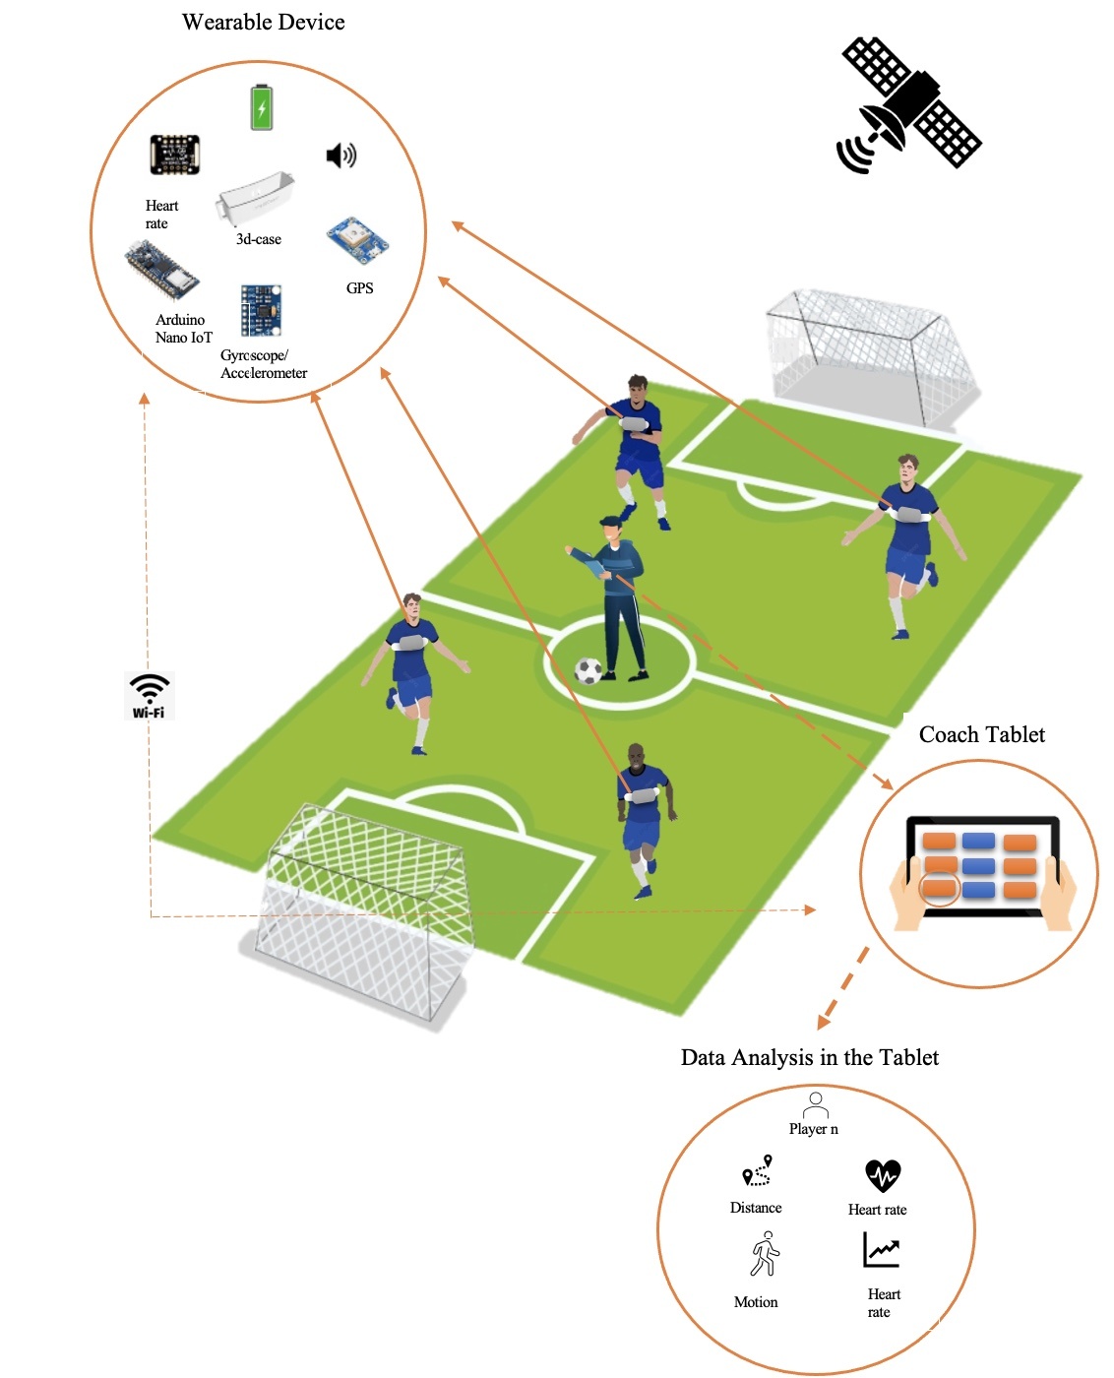

Figure 4. High-level Architecture

## Design alternatives

Smartphone devices includes similar design approach and can incorporate some of the functionality offered by IntelliCoach devices.

Smartphones are portable devices that combine typical mobile phone features with advanced computing power. It is a handheld gadget that combines different technologies and features to give a variety of functions beside voice communication. With a smartphone, users can connect to cellular networks for data connectivity, make and receive phone calls, and send and receive text messages. What differentiates smartphones, though, is their capacity to carry out operations typically reserved for PCs. They frequently employ operating systems with user-friendly interfaces and broad app support, like Android or iOS.

Smartphones include a variety of sensors on the hardware side. The gyroscope sensor measures rotation, whereas the accelerometer sensor detects motion and device orientation. The compass is provided by a magnetometer, and close objects are detected by proximity sensors. GPS allows for precise location tracking. These sensors can be different based on the model of the device. Thus, a smartphone can be a system that can meet same functional requirements of IntelliCoach. By using or creating application that can detect the heart rate, location, distance and speed, and predicted activity. As for the communication athlete and coaches can communicate through a typical voice call or using different communication protocols such as Wi-Fi or Bluetooth.

The design evaluation considers the compatibility with IntelliCoach. In IntelliCoach, Wi-Fi is utilized for connecting the IC device to a tablet, whereas the design alternative can employ Bluetooth, Wi-Fi, or GSM (Global System for Mobile Communications) for establishing the communication channel. As for speaker communication, IntelliCoach incorporates a button on the application that enables the coach to speak into the tablet's microphone, with the sound being played on the speaker of the IC device. The design alternative achieves this functionality by employing the embedded speaker within the smartphone.

Both design approaches can accomplish the same functionalities, Although the specific implementation may differ, both designs aim to provide comparable capabilities. However, smartphones will be difficult to place around the chest to obtain accurate heart rate readings. In addition, it will weigh more than IntelliCoach. As a result, the design alternative will not be practical to use in this case.

Table 12. IntelliCoach and Smartphone Comparison table

|  |  |  |
| --- | --- | --- |
| Comparison | IntelliCoach. | handheld transceiver (design alternative) |
| Protocol | Wi-Fi | Bluetooth - Wi-Fi - GSM |
| Connection Range | 50 meters | Approx. 72000 meter from cell tower |
| No. of features | * Measuring the traveling distance and speed * Heart rate * Heart rate zones * Gait analysis | * Measuring the traveling distance and speed * Heart rate * Heart rate zones * Gait analysis |
| Battery life | Less battery life due to Wi-Fi. | More |
| Weight | Less | More |

## Hardware design

### Microcontrollers

Due to the numerous various types and sizes of microcontrollers on the market, a comparison has been done in the tables below that show different component options such as small microcontrollers shown in table 13 and normal microcontroller shown in table 14 to assist in determining the best choice. Therefore, the chosen microcontroller is Arduino nano 33 Iot that is justified in table 18 section 5.5.

Table . Small microcontroller

|  |  |  |  |  |
| --- | --- | --- | --- | --- |
|  | Arduino uno Wi-Fi | Arduino Nano 33 IoT | Beetle ESP32-C3 | Teensy 4.1 |
| Image |  |  |  |  |
| Microprocessor | ATmega4809 | SAMD21 Cortex®-M0+ 32bit low power ARM MCU | 32-bit RISC-V single-core | ARM Cortex-M7 |
| Total number of input and output pins | 14 | 22 | 13 | 55 |
| Power consumption | 20 mA | 7mA | 25mA | 100mA |
| Weight | 25 g | 5g | 12g | 13 g |
| Dimensions | 53.4mm*68.6mm | 45mm*18mm | 25mm*20.5mm | 61mm*18 mm |
| CPU Frequency | 16 MHz | 64MHZ | 160 MHz | 600 MHz |
| Interface | USART/UART (1)  I2C (1)  SPI (1)  Wi-Fi  Bluetooth | UART(1)  SPI(1)  I2C(2)  PWM  Wi-Fi  Bluetooth | UART(2)  I2C(1)  I2S(1)  PWM (4)  SPI(1)  Wi-Fi  Bluetooth | CAN(3)  I2C(3)  SPI(3)  I2S(2) |
| Cost | $53.80 | $24 | $7.90 | $41.99 |

Table . Normal microcontrollers

|  |  |  |  |  |
| --- | --- | --- | --- | --- |
|  | Nucleo  F401 | Esp32 | Raspberry pi3 | Raspberry pi4 |
| Image |  |  |  |  |
| Microprocessor | STM32F401  32bit | Xtensa Dual Core 32-bit LX6 | Quad Core 1.2GHz Broadcom BCM2837 64bit CPU | Broadcom BCM2711, Quad core Cortex-A72 (ARM v8) 64-bit SoC |
| Total number of input and output pins | 50 | 36 | 26 | 28 |
| Power consumption | 200 mA | 120mA | 260 mA | 540 mA |
| Weight | 49.997 g | 250g | 42 g | 46g |
| CPU Frequency | 84 MHz | 80 MHz. | 1.4 GH | 1.5GHz |
| Interface | USART/UART (4)  I2C (3)  SPI (3) | USART/UART (3)  I2C (2)  SPI (4)  can | wireless, Bluetooth  USB  Ethernet  I2C  SPI  UART  PWM | wireless, Bluetooth  USB  Ethernet  I2C  SPI  UART  PWM |
| Cost | $13.83 | $17.88 | $35 | $35(1 GB RAM),  $45(2 GB RAM), $55(4 GB RAM), $75 (8 GB RAM) |

### Sensors

It is possible to implement the project's design using a wide variety of sensors with various types and levels of compatibility. The tables below display the alternative types of each sensor such as GPS in table 15, heart rate in table 16, gyroscope and accelerometer in table 17 that can be used in the design. The chosen sensors are Adafruit ultimate GPS,MAX30102 Blood Oxygen Heart Rate Pulse Detection**,** and MPU6050, table 18 section 5.5 justifies the choices.

Table . GPS

|  |  |  |  |  |  |
| --- | --- | --- | --- | --- | --- |
| GPS | Beitian Bn- 180 GPS | Beitian Bn- 220 GPS | Adafruit ultimate GPS breakout | SparkFun GPS-RTK2 | NEO-6M GPS MODULE |
| Image |  |  |  |  |  |
| Accuracy | 2 m | 2m | 1.8 m | 10mm | 2.5 m |
| Voltage | 3V-5.5V | 3V-5.5V | 3V-5V | 3.3V-5V | 3.6V-5.5V |
| Current | 50mA | 50mA | 20mA | 68mA-130mA | 45mA |
| Power consumption | 50mA/5.0V | 50mA/5.0V | 20mA/5.0V | 130mA/5V | 45mA/5.5V |
| Weight | 4.5g | 5.3g | 8.5g | 6.8g | 11.5g |
| Dimensions | ‎18mm*18mm | 22mm*20mm | 25.5mm * 35mm | 43.5mm * 43.2mm | 27.6mm * 26.6mm |
| Cost | $10 | $12 | $30 | $275 | $13 |
| Compatibility | Arduino windows | Arduino windows | Arduino  Raspberry Pi | Arduino  Raspberry Pi | Arduino  Raspberry Pi |
| Availability | Amazon | Amazon | Adafruit shop  Desertcart  Ubuy | Sparkfun shop | Amazon  Voltaat |

Table 16. Heart rate sensors

|  |  |  |  |
| --- | --- | --- | --- |
| Heart rate sensor | Heart Rate Pulse Sensor | MAX30102 Blood Oxygen, Heart Rate Pulse Detection | SparkFun Single Lead Heart Rate Monitor - AD8232 |
| Image |  |  |  |
| Total number of input and output pins | 3 pins | 8 pins | 20 pins |
| Voltage | 3.0 – 5.5 V | 1.7 – 2 V | 2.0 - 3.5 V |
| Current | < 4mA | 600 µA | 170 µA |
| Weight | 20 g | 20 g | 0.3g |
| Dimensions | 15.8mm (0.625″) | 5.6mm x 3.3mm x 1.55mm | 4 mm × 4 mm |
| Compatibility | Arduino | Arduino, KL25Z and other microcontrollers | Arduino |
| Accuracy | NA | 97.11% and 98.84% | 91.62% |
| Type | Optical HR sensor/ finger or earlobe | Optical HR sensor [LED] /wearable devices | ECG/forearms-legs-lower abdomen |
| Cost | $2.26 | $1.81 | $21.50 |

Table . Gyroscope & Accelerometer

|  |  |  |  |
| --- | --- | --- | --- |
| Gyroscope | MPU6050 (Gyroscope + Accelerometer + Temperature) Sensor Module | GY-91 MPU9250+BMP280 10-DOF 9-Axis Gyro Compass Accelerometer Module | SparkFun Triple Axis Accelerometer and Gyro Breakout - MPU-6050 |
| Image |  |  |  |
| Total number of input and output pins | 8 pins | 4 pins | 10 pins |
| Voltage | 2.375 - 3.46V | 2.4 – 3.6 V | 2.3 - 3.4V |
| Current | 5µA | 450 µA | 5µA |
| Acceleration range | Gyroscope ±250, ±500, ±1000, and ±2000°/sec  Accelerometer  ±2g, ±4g, ±8g and ±16g | ± 2g, ± 4g, ± 8g ±16g | Gyroscope ±250, ±500, ±1000, and ±2000dps  Accelerometer  ±2g, ±4g, ±8g and ±16g |
| Weight | 2.1 g | 5 g | 10 g |
| Dimensions | 4 x 4x 0.9mm | 3mm x 3mm x 1mm | 25.5 x 15.2 x 2.48mm |
| Compatibility | Arduino and Raspberry Pi | Arduino IDE and STM32[cortex] | Arduino |
| Cost | $6.29 | $11.80 | $32.50 |

## Hardware/Software to be used

Table . HW/SW needed

|  |  |  |  |
| --- | --- | --- | --- |
| Component name | HW/SW details | Platform | Justifications |
| Arduino nano 33 IoT  Arduino Nano 33 IoT — Arduino Online Shop | * SAMD21 Cortex®-M0+ 32bit low power ARM MCU operates at 64 MHz * Wi-Fi:   + IEEE 802.11b up to 11Mbit   + IEEE 802.11g up to 54MBit   + IEEE 802.11n up to 72Mbit * Bluetooth BR/EDR: 2.4 GHz 79 channels * Bluetooth BLE: 2.4 GHZ 40 channels * Size of 45mm X 18mm * Requires 7mA with 3.3 V. * 23 GPIO pins * 1 I2C interface | NOT APPLICABLE | The key reason for adopting the Arduino nano 33 IoT microcontroller is that it offers numerous capabilities that are ideal for our suggested wearable and portable design. It is also easily portable due to its compact size, which fulfills the design requirement given in table 4.  It contains an integrated Wi-Fi module and Low energy Bluetooth that can be utilized to wirelessly transfer sensor data without the requirement for an additional module. It also has enough analog input ports to connect to all the sensors that will be employed. Lastly, it is inexpensive in cost and power consumption, which helps the design meet the battery life constraint specified in table 4. |
| Adafruit ultimate GPS  746 Adafruit Industries LLC | Development Boards, Kits, Programmers |  DigiKey | * Supply voltage 3V - 5V * 22 tracking and 66 searching satellites * The size of Patch Antenna: 15mm x 15mm x 4mm * The Position Accuracy: 1.8 m * Size of 25.5 mm x 35mm * Accuracy: 1.8m | NOT APPLICABLE | The primary reason for selecting Adafruit ultimate GPS is its high tracking sensitivity and rapid position updates to track the movement of the users. Therefore, it will produce reliable data, which is critical in our project to detect live movement.  Furthermore, its relatively small size and low power consumption satisfy our design constraints, as shown in table 4. |
| MAX30102 Heart Rate Pulse Detection    MAX30102 Blood Oxyge, Heart Rate Pulse Detection Module - ElectroPeak | * Optical HR sensor [LED] /wearable devices * Supply voltage 1.7V - 2V * The accuracy is up to 98.84% * Weight of 20g | NOT APPLICABLE | The MAX30102 sensor was chosen to monitor the user's heart rate, which would be utilized to establish HR zones for the players. It offers a high reading accuracy as well as compatibility with our microcontroller and software. Its light weight is excellent for our wearable device, and it meets the design constraints listed in table 4. |
| MPU6050  6DOF MPU-6050 3 Axis Gyro With Accelerometer Sensor Module For Arduino | * Gyroscope, Accelerometer, and Temperature Sensor Module * Triple-axis gyroscope with range of ±250, ±500, ±1000, and ±2000 °/sec * Accelerometer   + ±2g, ±4g, ±8g and ±16g * Supply voltage 3V - 5V * Size of 21.2 x 16.44mm and weight of 2.1 g | NOT APPLICABLE | MPU6050 was selected because it accurately detects velocity, direction, acceleration, displacement, and other motion-related parameters by combining a three-axis accelerometer, a three-axis gyroscope, and a temperature sensor into a single sensor.  The sensor's accuracy and computational power that improves speed are critical because they comply with the design constraints of accuracy and prediction speed given in table 4. Furthermore, its compatibility with Arduino makes it suitable for our project. |
| Multi-function mobile phone internal speakers Multi-function Mobile Phone 8 Ohm Mylar Speaker 0.5w Internal Speakers For Mobile  Phone Speaker Driver - Buy Mobile Phone Speaker,8 Ohm 0.5w Internal Speakers ,Internal Speakers For Mobile Phone Product on Alibaba.com | * Impedance: 8 ohm * Weight: 1.1g * Size: 17*12*4.0 mm * Power supply: 0.5 W * Cost: $0.38 | NOT APPLICABLE | Mobile phone internal speakers were chosen due to their small size, light weight, low power consumption, and inexpensive cost in comparison to other speakers that meet the design constraints listed in table 4.  Moreover, Speakers are crucial to the project's implementation in order to build communication between the coach and the athlete. |
| CR2032 CR 2032 3V Lithium  Maxell CR2032 Lithium Button Cell 3V Battery – MYBATTERY.IN | * Type: lithium * Volt: 3.0 V * Battery life: up to 12 hours * Price: $5.69 * Weight: 3 g | NOT APPLICABLE | Maxell CR2032 batteries were selected since they are among the smallest battery sizes that could fit in with our design. In addition, due to the technical challenges Maxell CR2032 was the only choice that will work with our design. |
| Arduino IDE  Arduino Integrated Development Environment (IDE) v1 | Arduino Documentation  | Arduino Documentation | * C and C++ is used to develop the code and upload it to the board * Interacts with the board using basic I/O boards and a programming environment. * Suppliers: Arduino and GitHub | Runs on Windows and MacOS | Arduino IDE software was chosen due of its compatibility with the Arduino nano 33 IoT microcontroller. It contains a variety of features that assist with developing and debugging code, as well as a fast-uploading speed of the code. |
| Fritzing   | * It is a software in electronic design automation. * Provide 3 views which are Breadboard, Schematic and PCB views. * Formats for SVG, PNG, and JPEG are supported. | NOT APPLICABLE | Fritzing software will be used to model a digital circuit. It was chosen since it allows us to replicate the project circuit into many forms, including PCB layout, for further implementation. Furthermore, it allowed us to create or download our own elements as these features were not offered by other applications. |
| Onshape | * Onshape is a CAD software that is specifically designed for 3D printing workflows | NOT APPLICABLE | We choose Onshape software for our 3D printing process because it improves collaboration, accessibility, version control, design flexibility, and an integrated workflow. This makes it an appropriate choice for getting effective and high-quality 3D printing results. |
| Figma  Figma SVG Vector Logos - Vector Logo Zone | * Figma is an online tool for interface design that facilitates collaboration and has additional offline functionality made possible by desktop programs. | Runs on macOS and Windows operating systems | We opted for Figma software for our UI design because of its collaborative features, user-friendly interface, and efficient workflow. Because of version control and simple access provided by its cloud-based platform, the design process is expedited. We successfully produced an aesthetically pleasing and user-friendly interface using Figma's powerful features. |
| Android Studio   | * Official Integrated Development Environment (IDE) for Android app development * It supports several programming languages, including Java, Kotlin, and C++ | Runs on Windows, Linux,  macOS operating systems | Android studio was chosen as our primary code editor software since it provides a powerful and comprehensive development environment that interfaces with other tools in the Android development ecosystem. These capabilities include creating user interfaces, debugging, testing, and packaging apps for deployment in app stores, notably Huawei AppGallery.  An application and graphical user interface (GUI) for the tablet view will be developed using Android Studio. Additionally, it is compatible with hundreds of languages, including Java, on which we will be working. |

* + 1. **Circuit and connection diagrams**

In addition to the final integrated case design, the case prototypes and device connection schematics will be demonstrated in this part.

Figure 5. and figure 6. Shows the connections of the main component the Arduino nano 33 IoT with the subcomponents. There are five connections with microcontroller ground. Each of the 3 sensors (heart rate, GPS, gyroscope accelerometer), battery, and buzzer are wired to GND pin of the Arduino nano 33 IoT. To power the system using the battery, the positive terminal of the coin battery was connected to the VIN pin. As for gyroscope accelerometer and heart rate sensors that uses the SCL and SDA pins for sending the data they were connected to the SCL and SDA pins of the board. In addition, the GPS RX and TX pins the are responsible for sending and receiving data were connected oppositely to the TX and RX pins of the board. Lastly, in addition to the ground connection of the buzzer the positive terminal was connected to pin D6 which is a digital pin that can act as an input pin or output. Both figures show the connections but in different layouts.

* + - 1. 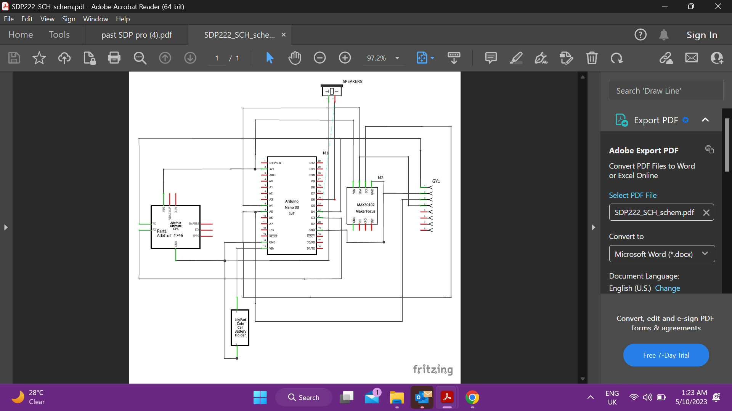 **IntelliCoach schematic Diagram**

Figure . Schematic Diagram of IntelliCoach Connection

* + - 1. **IntelliCoach Circuit diagram**

Figure . Breadboard diagram of IntelliCoach Connection

* + - 1. **PCB Design**

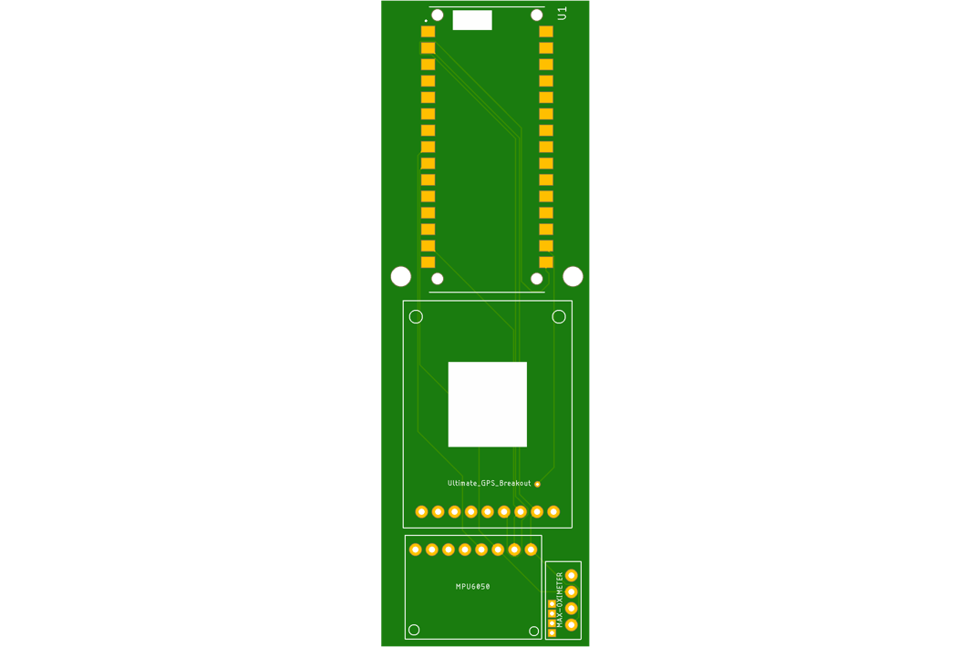Figure 7 in this section illustrated the IntelliCoach PCB design

Figure . IntelliCoach PCB design

* + - 1. **Intellicoach Casing 3D Modeling**

Onshape software was suitable for us to use to combine all the components of IntelliCoach into one enclosure. We developed multiple designs before reaching a suitable one that satisfies IntelliCoach device. Figure 8 illustrates the IntelliCoach device case in its first version.

Figure 8. IntelliCoach initial device case design

Figure 9 below shows how the case's construction has been changed to improve the athlete's comfort, that is, to make it concaved on the chest area. Moreover, we added a secured insertion of the heart rate sensor to provide more accurate readings.

Figure 9. IntelliCoach modified device case design.

In the final design, we made the edges smoother and the device smaller for practicality. We also made changes to the handles which were used in the first version as shown in figure 8 previously to fasten the strap; we added a rectangle hole for the Arduino Nano board's USB connector to make it easier to upload code without having to open the box each time as well as several small holes for the speaker. Two magnets will hold the lid in place while a screw will secure the PCB board inside the case to minimize the movement of the PCB.

Figures 10 and 11 bellow show the final design of the IntelliCoach case design:

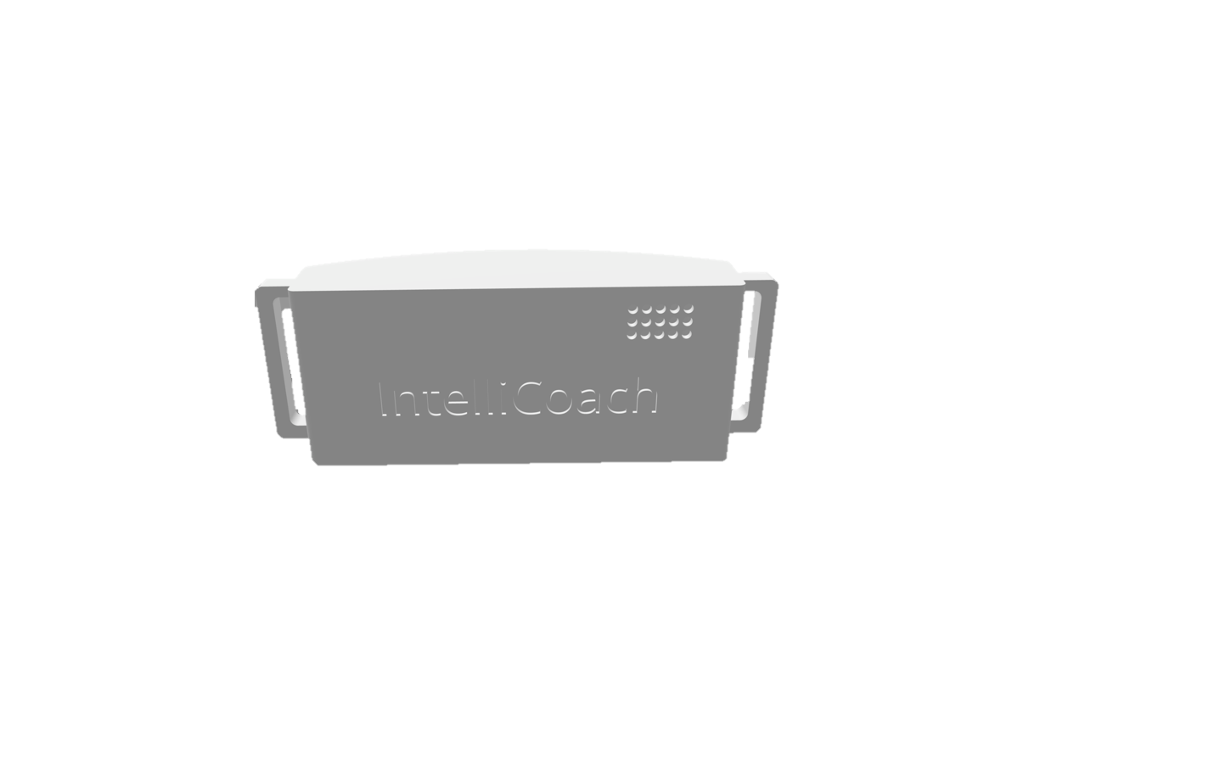

Figure 10. Front side of the case 3D design

Figure 11. Back side of the case 3D design

* + 1. **Integrated Hardware design**

The integrated IntelliCoach device prototype is shown in Figure 12. It has a 3D case that is made to accommodate the speaker, batteries, and sensors that are connected to the PCB. Speaker holes are built into the case to allow clear audio output. A strap is also included to assist the device stay fastened while being worn.

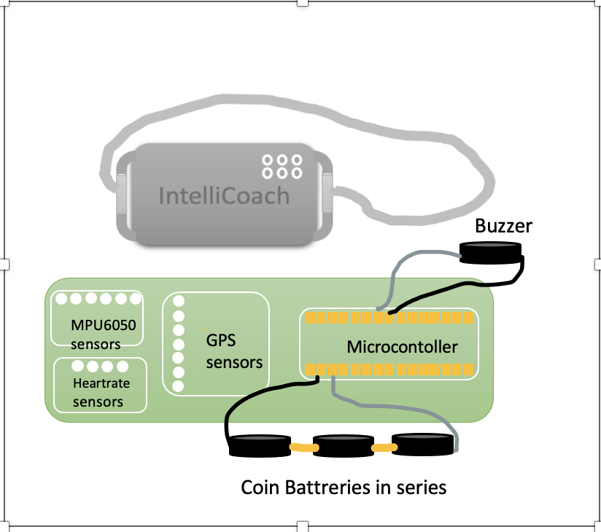

Figure . Integrated IntelliCoach device prototype

## Software design

This section will discuss the software design of the project's two main parts including communication and the Tablet application. The system's overview is shown in figure 13 below, which shows the main stages that the system will go through in order to visualize the whole system.

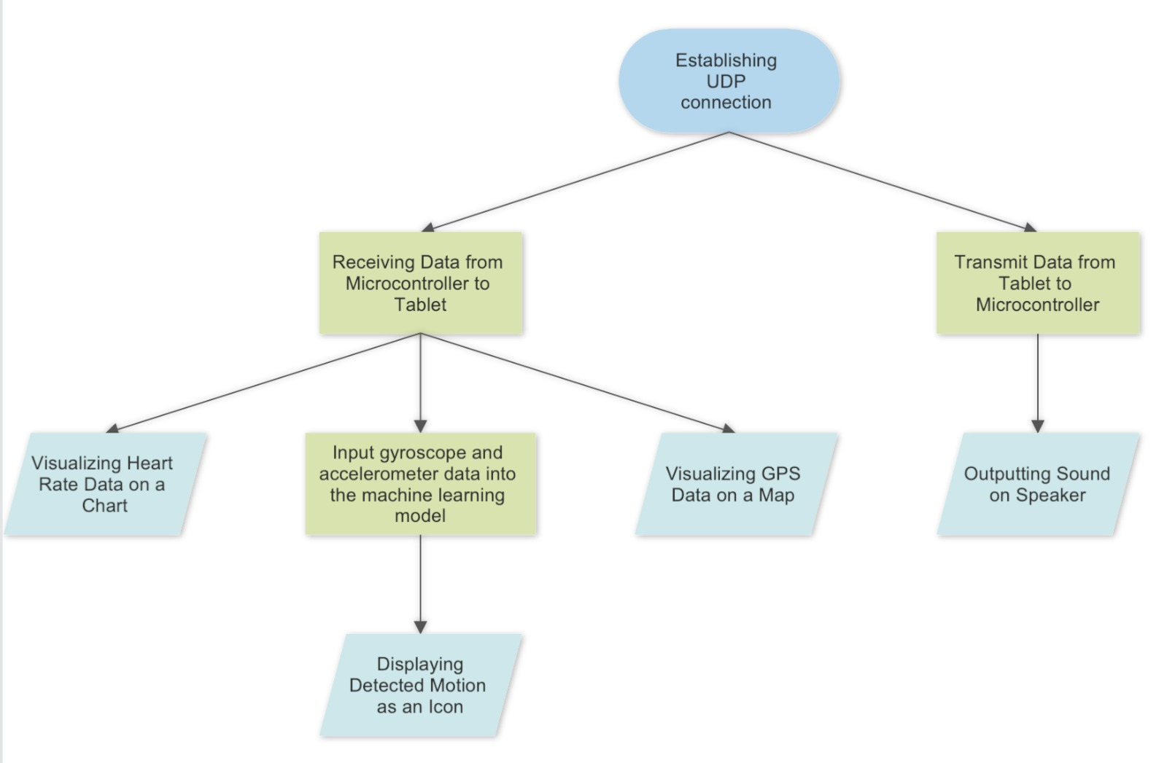

Figure . System overview

### 5.6.1. Communication

Figure 14. communication overview

The choice between TCP (transmission Control Protocol) and UDP (User Datagram Protocol) is made based on the application's particular needs and the trade-off between reliability and real-time delivery. TCP, the reliable protocol, makes sure that data packets are delivered in the right order. It works effectively in situations where ensuring the completeness and integrity of transmitted data is essential.

However, because UDP is a connectionless protocol, it cannot ensure accurate delivery or packet ordering. In contrast to TCP, it provides lower latency and overhead. Real-time applications that put a high priority on low latency and quick transmission frequently use UDP. Lower latency must be given priority in our project design above reliability, particularly when the coach wants to alert the athlete in an emergency through the speaker.

The method of transmitting information between the server and client has been set up via the UDP protocol. This allows for the transmission of data from the microcontroller located on the Arduino IDE using C language to the tablet which has been programmed in Java using Android Studio. The code comprises various functions that handle tasks such as configuring the wireless connection to the IntelliCoach Tablet application, capturing data from the sensors, and computing crucial features that will be supplied to the ML model at a later stage.

Additionally, a reverse communication channel has been established to transfer alert signals from the tablet application to the microcontroller. The speaker will play the alert signal, which will be received through this communication channel after clicking on the buttons that are shown in figure 15 below. Alert sounds are transmitted from the tablet application to the IntelliCoach device as part of the communication between the two devices. UDP, which is commonly utilized for fast network communication as mentioned earlier, is employed to accomplish this. The IP address of the microcontroller, which is the part of the IntelliCoach device that receives and processes the alert sounds, is assigned within the Android Studio program to enable this communication. The application and microcontroller can connect to each other via a network using this IP address and the port assigned. On the Arduino side, the microcontroller listens to an assigned port for incoming UDP packets. Information associated with the alert sounds that should be played by the IntelliCoach device's speaker is found in these packets. Figure. 15 illustrates the three various alert types that can be sent: Excellent, Focus, and Stop. The microcontroller analyses the information included in incoming UDP packets to decide what kind of alerting should be played. The IntelliCoach device's speaker is then instructed by the microcontroller to play the matching alert sound.

### 5.6.2. Tablet Application

As justified in section 5.5, Figma software was used to build the user interface preview as shown in figure 15 below. This visualization was designed to illustrate the design of the tablet application view, which will be implemented in the next stage of development.

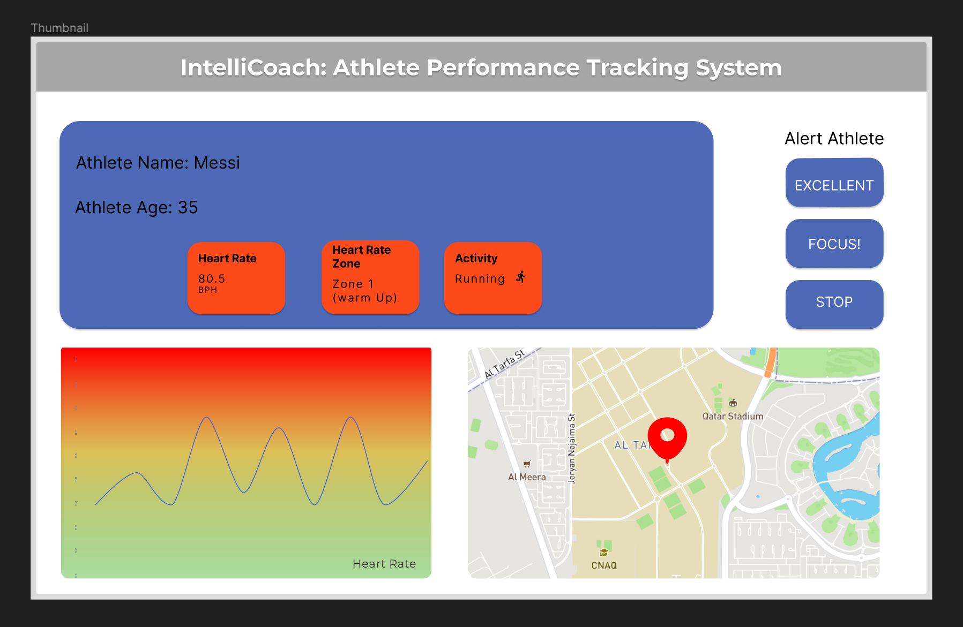

Figure 15. IntelliCoach GUI interface

##### **5.6.2.1. Heart rate zone**

The process by which the application calculates the heart rate zones is shown in the flowchart diagram in Figure 16. The user is prompted to enter their age. The application then uses this data to perform two equations that establish the heart rate zones.

Figure 16. Heart rate zone flowchart

According to section 2.1.2 eq. 3, firstly we calculated the max heart rate using the age the user has entered assuming both athletic genders. The age predicted maximal heart rate (APMHR), which decreases to anticipate an individual's maximum heart rate for each year, is represented by a factor of 0.8. The second equation determines which zone the user is in by calculating the percentage of the maximum heart rate that may be predicted by dividing the BPM (beats per minute) by the result of the maximum heart rate.

$Max percentage = \frac{bpm }{Max heart rate}$ (8)

##### **5.6.2.2. GPS**

The GPS sensor's data transmission over the UDP communication channel is critical since it supplies two critical pieces of information: latitude and longitude. The latitude and longitude coordinates will be converted from Degrees Minutes Seconds format to Decimal Degrees using the eq. 9 below.

$$Decimal = Degrees + Minutes/60 (9)$$

These numbers are utilized to precisely locate the player's location, which is subsequently shown on the map as a red marker, as shown in figure 15 above. The map view provides a graphical depiction of the player's position, allowing them to see where they are in relation to other points of interest. We will utilize the Huawei Map Kit to integrate and implement the map view. This tool will be extremely useful for tracking the athlete’s distance and speed during training.

##### **5.6.2.3. Speed and distance**

Calculations are required to ensure accurate display of speed and distance in the tablet application. The below-mentioned equation (10), which will be expanded on further in section 6.2.1.3, is used to convert speed from knots to meters per second.

$speed in meters per second = knots × 0.514444$ (10)

Furthermore, in order to accurately present the distance, calculations involving the speed in meters per second, previous time, and current time will be used, as shown in the provided equation (11).

$$distance = speed in meters per second * (current time - previous time) (11)$$

### Machine Learning Models

We had two models to choose from in our project: the SVC (Support Vector Classifier) and the LSTM (Long-Short Term Memory). We initially decided to implement LSTM because it is effective for handling time series or sequential data. For our prediction task, LSTM allowed us to consider a window of data rather than analyzing individual packets. However, due to the complexity of its layers, we encountered difficulties when converting the LSTM model into TensorFlow Lite format and integrating it into Android Studio.

We reconsidered our options as a result and decided to implement the SVC model. SVC is a widely used algorithm in human activity recognition and has been demonstrated to be highly accurate in multi-class classification problems, The SVC model consistently outperformed the others in terms of accuracy during our evaluation process when comparing the performance of various models, as shown in the figure 17. due to this, we are convinced implementing the SVC model will assist us to achieve our activity recognition task as accurately as possible.

Figure 17. ML Accuracy

In our classification model for distinguishing between sitting, standing, and walking activities, we have evaluated its performance using a confusion matrix. The confusion matrix for our model is represented in figure 18 below.

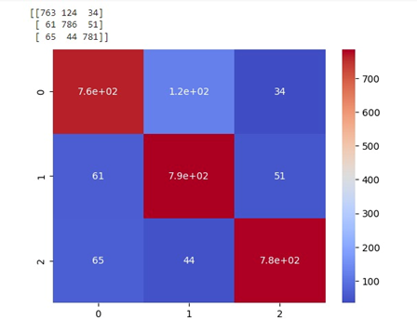

Figure 18. Confusion Matrix

Using a confusion matrix for evaluating the performance of our classification model, we found that it correctly identified 763 instances as sitting, 786 instances as standing, and 781 instances as walking. According to these results, our model performs well in correctly classifying instances of sitting, standing, and walking. However, it experiences difficulties in accurately predicting negative instance, particularly for sitting and standing activities, which results in false positive predictions.

**Data Collection and preprocessing for training the ML models**

The IntelliCoach device was placed on the athlete's chest during data collection, specifically with the MPU6050 sensor positioned to the right. The athlete spent 30 minutes moving in a various gait, including sitting, standing, and walking. This allowed to accumulate the data throughout these processes, which would later be utilized to train and evaluate the machine learning (ML) model.

We solely utilize the accelerometer and gyroscope data to predicted motion activities such as walking, standing, and sitting utilizing the MPU6050 sensor. The accelerometer monitors linear acceleration along the x, y, and z axes, providing information on the amount and direction of movement. Rotational motions involving the x, y, and z axes are gathered up by the gyroscope. We train a machine learning model by extracting features from the sensor data, such as rotation and acceleration. In order to effectively forecast various motion activities, the model learns the patterns and connections between these characteristics and the observed motion activities in the training data.

Preprocessing will be performed on the collected data to get it prepared for the machine learning (ML) model training. To ensure that the data is consistent across all files, the first step in this process will be to create a list of common column names. The time column will then be removed from the dataset after the unprocessed data files have been read into dedicated data frames.

The columns will be formatted to only contain numerical values in order to make the data more manageable. This preprocessing step will be applied to the data collected for the three activities of sitting, standing, and walking.

## New-gained knowledge

Throughout the process of both hardware and software design many different knowledges were gained. When choosing which protocol to use for communication TCP/UDP were taken into consideration while deciding how to establish the connection during the implementation phase. And along that procedure, we discovered the fundamental ideas and software requirements needed to enable communication between the two protocols and the situations in which they are most appropriate for creating IntelliCoach.

Also, while developing the GUI Figma was introduced as a tool to help in designing and visualizing the IntelliCoach Application before starting the development. Furthermore, the process that was supposed to be after developing the application introduced us to AppGallery platform which is used for Huawei tablet to allow us to officiate our application if needed in the AppGallery.

Not to mention, the hardware part of the project introduced us to a new perspective when it comes to connecting the pins between the sensors and Arduino board. It was acknowledged that each sensor has its own communication with the board as well as each pin and connection serve a different purpose.

Additionally, during the testing phase, Audacity software was used to edit the audio files that were intended to be played by adapting the sampling rate to be compatible with our microcontroller and changing the file formats into forms that could be processed.

When speaking of machine learning CoolTerm and Google Collab helped in the process of collecting data and processing it to create a model that was used in the gait analysis. The collection of data from the MPU6050 sensor took place in CoolTerm software while Google Collab was the tool that helped in creating the machine learning module.

Moreover, as part of the design process, we learned about the Model-View-Controller (MVC) architecture, which we used while working with Android Studio. This new knowledge was obtained through online resources such as tutorials, forums, and documentation supplied by Android Studio. By applying the MVC architecture, we were able to create a better organized and efficient system that isolates the application's responsibilities and promotes code reusability. During this process, we also acquired important experience working with Android Studio and leveraging its different features and tools to aid in the development of the application.

Finally, Termux application was introduced to be used as a terminal that allowed us to receive sent packets from Arduino and display them in the terminal of Termux.

# Implementation

The proposed project includes the development and integration of both subsystems' hardware and software. The entire implementation procedure is covered in this section.

Our project aims to enable athletes to track their motion, location, and heart rate while training. When an athlete places the IntelliCoach device on their chest, the heart rate, GPS, and MPU6050 sensors begin to collect data. This data is wirelessly transferred through Wi-Fi to the coach's tablet. On the coach's tablet, the data is received and displayed in three main ways: The athlete's heart rate zone is first determined depending on their age and then displays the live heart rate as a chart. The location of the athlete is then determined by processing the GPS data. Finally, the MPU6050 data is fed to a machine learning model to detect the athlete's gait analysis during training.

## Hardware implementation

The following demonstration in figure 19 illustrate how different sensors, speaker, and batteries are fully integrated onto a PCB using the circuit connection diagrams in section 5.5.3. These components are integrated in a seamless manner to create a system that works effectively with some changes due to technical challenges that are faced when implementing the integrated system. As for the battery, three more-coin batteries were added in series to fulfill the power consumption and solve any potential power shortage. Because each sensor required a 3-volt battery, this was essential. These batteries may be connected in series to create a voltage of 9 volts, ensuring sufficient power supply for the integrated system. In terms of speaker, it was determined that alert sounds were going to replace the place of verbal real-time communication in order to overcome technical difficulties and meet project deadlines. This alternative approach was chosen due to challenges when playing sound files in the required format without using external modules when using some libraries such as pitches.h that include notes based on variant frequencies.

By using alert sounds, the coach is able to continue leading the athletes effectively because each sound has a distinct meaning. The alert sounds offer a practical solution that, despite the shift from verbal communication, it enables clear communication between the coach and athletes within the established technical constraints and time frame. Figures 20 and 21 also show the strap that securely connects the wearable device to an athlete's chest.

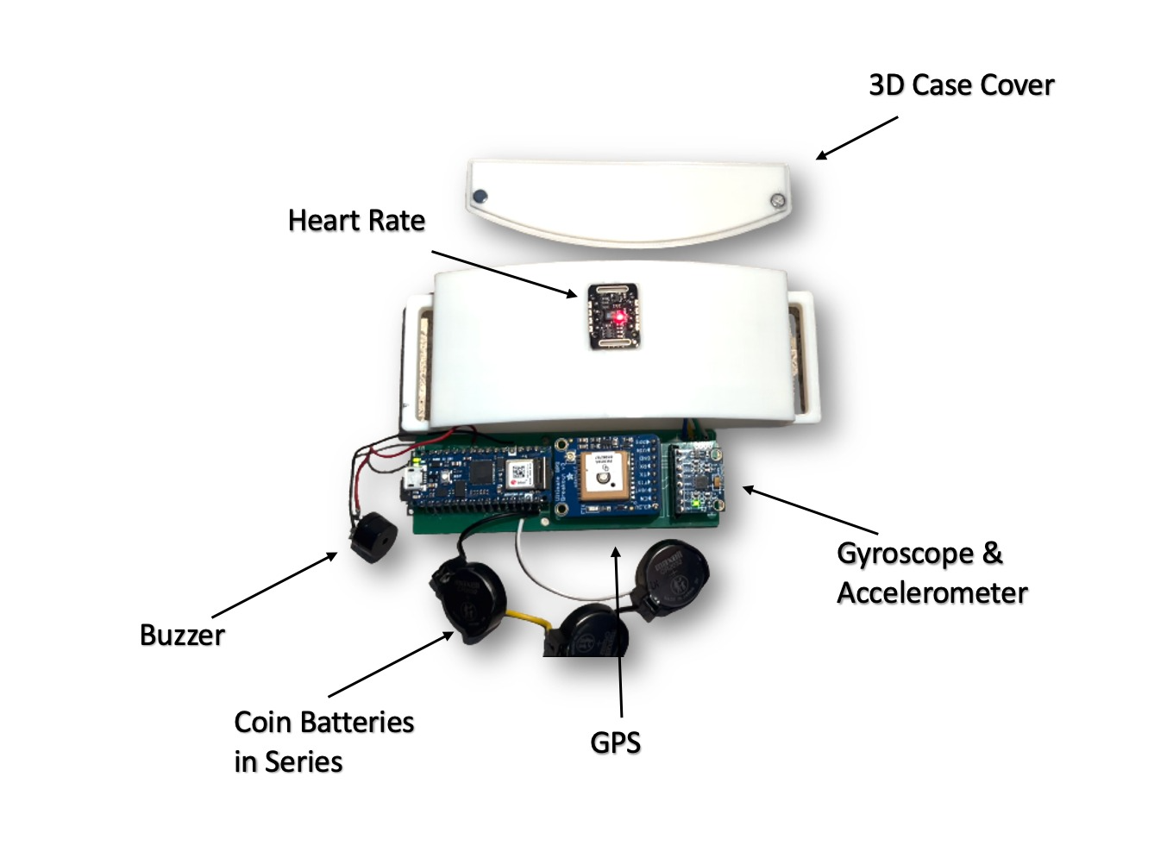

Figure . Embedded connections

Figure 20. Front side of IC device

MAX30102 Heart rate sensor

Figure 21. Back side of the IC device

## Software implementation

In this upcoming section, there will be three main subsections that will address the communication component, the implementation of the Graphical User Interface (GUI), and the use of machine learning. As mentioned in the previous section, the programming languages used for the IC device are Java on Android Studio and C on Arduino. The code for the sensors includes various functions that are responsible for establishing wireless communication with the Tablet Application, obtaining data from the sensors (gyroscope and accelerometer, heart rate, and GPS), and extracting relevant information features required for the ML models. Additional information regarding the software implementation code can be found in Appendix D.

### Communication

##### **Wireless connection**

We have developed an Android software program that facilitates data exchange between a coach's tablet and an Arduino device, which runs sensors that provide sensor readings. The software communicates through UDP protocol and is built around a MainActivity class that implements interfaces for OnMapReadyCallback and UdpReceiver.OnMessageReceivedListener. The MainActivity class defines variables that hold the IP address and port number of the Arduino device as well as the tablet running the program. It also uses the startReceiver() method of the UdpReceiver class to start a receiver that listens for incoming packets on the provided server IP address and port number. Furthermore, the application has a sendUdpMessage() method for sending UDP messages to the Arduino device's IP address and port number. The run() function of the UdpReceiver class is responsible for receiving incoming packets and continuously listening for fresh data. Please refer to Appendix D for more information on code implementation.

private static final String *ARDUINO_IP* = "192.168.43.54";  
private static final int *ARDUINO_PORT* = 8888;  
  
private static final String *SERVER_IP* = "0.0.0.0";   
private static final int *SERVER_PORT* = 8888;

We establish the connection and communication in the arduino communication implementation by loading two Arduino IDE libraries into the code. The first library, Wifi.h, allows the microcontroller to connect to the network via Wi-Fi, while the second library, WiFiUdp.h, allows packet transmission and reception using the UDP protocol.

#include <WiFi.h>

#include <WiFiUdp.h>

The WiFiUDP class instance is created and assigned to the Udp object, which is used to send and receive UDP packets across the network. The IP address and port number of the UDP server with which the board will communicate are supplied using the IPAddress class and the udpServerPort variable. In the Arduino IDE, the serial monitor is used to print notifications to the user that indicate the status of the connection process. The udpServerPort variable and the Udp.begin() method are used to configure the board's UDP communication port, allowing for speedy and effective network connectivity.

##### **Sensor’s data**

The sensors' data is an essential aspect of our project, and we utilized several libraries to read this data of each sensor such as the MAX30105, MPU6050 and GPS sensors and make use of their functions as shown in figure 22 below.

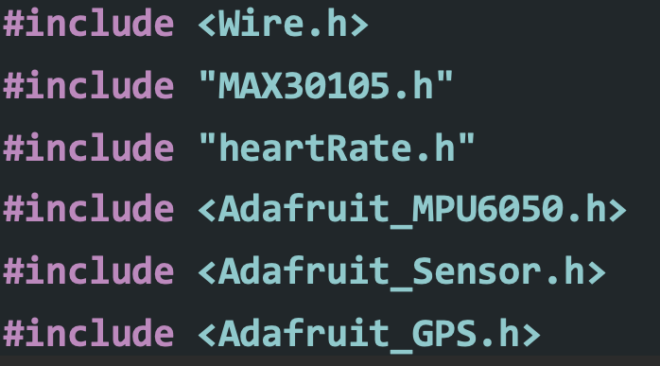

Figure 22. Libraries used

In addition, the Arduino code defines the variables that will contain the data collected from each sensor and will be transmitted as a packet to the application. Furthermore, the code computes the beats per minute, and calculates the average BPM over a period of time to give a more accurate reading, values of the gyroscope readings along the x, y, and z axes as well as the measured values of acceleration along the x, y, and z axes for machine learning. In addition, the latitude and longitude are outputted via GPS data on frequent intervals to guarantees that latitude and longitude are formatted correctly to be converted in the Android Studio for the map.

##### **Sending and receiving data**

Receiving messages in Android Studio is accomplished through the onMessageReceived function, which separates the text into substrings using a delimiter and stores the results in an array named "data." After that, the array is iterated through to extract specific values such as BPM, Average BPM, Time, acceleration axis, gyroscope axis, latitude, longitude, speed and distance depending on their prefixes and save them in variables. The retrieved values are then shown in the user interface. Furthermore, translating data from one format to another, such as changing geographical coordinates from the DDMM.MMMM format to decimal degrees, is one of the obstacles. In this scenario, the latitude and longitude values from a received message are extracted and transformed to decimal degrees by a series of mathematical procedures. These transformed numbers are subsequently used in numerous ways throughout the program, such as updating the GPS latitude and longitude coordinates for use in the Huawei map.

float dddmm = Float.*parseFloat*(item.substring(10));  
 float degrees = (float) Math.*floor*(dddmm / 100.0f);  
 float minutes = dddmm - degrees * 100.0f;  
 longitude = degrees + minutes / 60.0f;

Additionally, the implementation includes generating click listeners for buttons that send UDP messages using the "sendUdpMessage" method to initiate the playing of various tones.

Furthermore, once the speed and distance data are received and parsed, the speed value is initially expressed in knots. To ensure consistency, we must convert it into meters per second using the above-mentioned equation (10). Moreover, the distance is calculated by multiplying the speed in meters per second by the time difference between the current and previous measurements, as shown in the provided equation (11). Based on the updated speed value, we can accurately calculate the distance traveled and display both speed and distance data as shown in figure 23 below. The code snippet below demonstrates how to implement speed and distance on Android Studio.

} else if (item.startsWith("Speed=")) {  
 speed = Float.*parseFloat*(item.substring(6));  
 speed_mps = speed * 0.51444f;  
} else if (item.startsWith("Distance=")) {  
 distance = Float.*parseFloat*(item.substring(9));  
 distance = speed_mps * (milliseconds - prevTime) / 1000.0f;  
  
}

### GUI implementation

In the tablet application development, graphical user interfaces (GUIs) are often used to display data to users in a visually appealing manner. This involves using widgets, views, and layouts to create user interfaces for the app. In this context, this section describes various GUI implementations in an Android app.

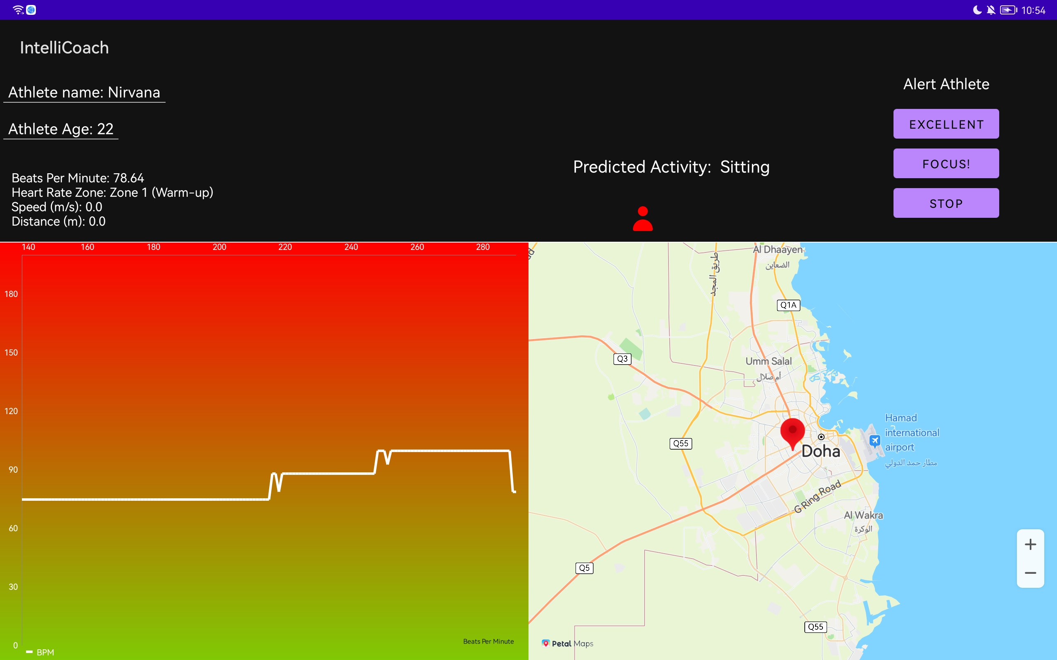

Figure 23. GUI implementation

The initial implementation comprises updating a TextView element with the data collected from the sensors. These data collected include the beats per minute, heart rate zone, speed and distance.

We utilized a technique that determines the heart rate zone as described in section 5.6.4.1 above. The method, as shown in the code below, generates a line chart to display heart rate data, where the data set is created during app setup and data is added dynamically.

data.addEntry(new Entry(set.getEntryCount(), bpm), 0);  
 data.notifyDataChanged();  
 chart.notifyDataSetChanged();

In addition, to ensure a visually consistent representation of the chart, we implemented the "addEntry" method, which takes the beats per minute (BPM) as input. We compute the average of ten consecutive BPM readings using this method. This average value is then used on the chart to display a smoother trend line. This procedure is illustrated by the code snippet provided below.

if (*counter* % 10 == 0) {  
 float average = *sum* / 10;  
 *sum* = 0;  
 *counter* = 0;  
 data.addEntry(new Entry(set.getEntryCount(), average), 0);   
}

The Huawei Map SDK is used to display a map in the third implementation. The API key has been configured in App Gallery Connect, and the MapView is ready to display a map. When the map is ready to use, the OnMapReady function is called, and the latitude and longitude coordinates are shown as a red marker above the player's location on the map using the code below.

MarkerOptions markerOptions = new MarkerOptions().position(location);  
 hMap.addMarker(markerOptions);  
 hMap.moveCamera(CameraUpdateFactory.*newLatLngZoom*(location, 10f));

The methods askUserForAge() and askUserForName() are important in the final implementation for creating a dialog box that prompts users to enter their age and name, as seen in figures 24 and 25, respectively. These methods use the AlertDialog.Builder class to construct a dialog box and the EditText class to receive user input. The data is presented on the EditText object once the user enters their information. Alternatively, the age provided will be used in mathematical equations, as shown in eq. (8) above, to help select the suitable zones. While the code behind these methods is sophisticated, their implementation gives users with a seamless and intuitive experience.

Figure 24. Dialog to ask user to enter their name

Figure 25. Dialog to ask user to enter their age

### Machine Learning

##### **Machine Learning Training and Testing**

For the machine learning approach, we have implemented a machine learning model using SVC (Support Vector Classifier) algorithm to recognize human activity from sensor data. As mentioned in 5.6.3. (Machine Learning Models) the sensor data is collected from the sensors, and it contains sensor measurements such as accelerometer and gyroscope. The model is trained on the dataset, which has data collected from 3 subjects performing three different activities, including standing, walking, and sitting. The code loads important libraries and prints the TensorFlow version, then connects to the Google Drive to read the combined data file in CSV format.

The data was preprocessed before being split into two parts: the actual data and the class labels. The class labels identify the corresponding activity for each instance, and the data contains the sensor measurements (accelerometer and gyroscope readings) for each instance.

# Data Labels

X_train = train_df[train_df.columns[:6]]

# Class Labels

y_train = train_df[train_df.columns[6:7]]

We encode the class labels into numerical values to ensure compatibility with machine learning algorithms. In this case, we assign the "Sitting" activity the value of 0, the "Standing" activity the value of 1, and the "Walking" activity the value of 2.

from sklearn.preprocessing import LabelEncoder

encoder=LabelEncoder()

y_train=encoder.fit_transform(y_train)

In addition, each model's accuracy is assessed after being trained using a variety of algorithms, including the Support Vector Classifier (SVC). The SVC model is chosen in accordance with the accuracy results covered in section 5.6.3. Additionally, it is saved utilizing the pickle library. The TensorFlow Lite model is then created and saved.

# Fit the data in the pipeline to train the model

fit_models = {}

for algo, pipeline in pipelines.items():

model = pipeline.fit(x_train, y_train)

fit_models[algo] = model

# Saving the svc model using pickel

with open('model_svc.pkl', 'wb') as f:

pickle.dump(fit_models['svc'], f)

In conclusion, the Integration of an SVC ML Model showed moderate accuracy. Through extensive training using various data sets that cover a variety of activities, improvements could be made. However, the Project's Time Frame Limited the Amount of Training.

##### **Machine Learning GUI**

A java code has been implemented for an Android application that can detect the activity of a person using machine learning. The app receives sensor data from an external source via the User Datagram Protocol (UDP). The sensor data includes accelerometer and gyroscope readings from a device worn by the person. The app then uses TensorFlow Lite, which is a machine learning framework for mobile devices, to classify the activity. The machine learning model is trained to classify between three activities: walking, standing and sitting. We have trained the model using Google Collab as mentioned in section 6.2.3.1.

Once the classification process is complete, the app displays the predicted activity and the confidence level of the prediction on the user interface. Additionally, the app changes the displayed icon based on the predicted activity as shown in the figure 26 below. The Android SDK is used to display and manipulate user interface elements such as TextView and ImageView. There are also helper functions included in the code, such as FloatListToFloatArray and classifyActivity, which help with the processing and classification of the data. Overall, the code provides an example of how machine learning can be used to develop a mobile application that can recognize human activities.

Figure 26. Predicted activity

**Implementation challenges:**

During the implementation phase, our team encountered several hardware and software challenges. These challenges included:

* Consolidating multiple sensors into a single Arduino code and ensuring compatibility with the appropriate libraries.
* Establishing effective communication between the tablet and microcontroller, as well as determining the optimal protocol to use between UDP and TCP and thoroughly testing each option.
* Designing a wearable device that did not restrict user movement, requiring us to fit all device components into a compact compartment.
* Team's lack of experience in application development, as all members were computer engineering students. This necessitated learning essential skills from scratch to build a unique application that connects to the tablet and plots the data such as the map and chart data.
* Converting the audio file into an appropriate format for use in the Arduino code, without the use of an SD card module.
* Implementing the real-time communication using the speaker due to compilation errors faced in Arduino IDE.

Despite these challenges, our team worked relentlessly to overcome each one, eventually delivering a practical and distinctive product.

## New-gained knowledge

Throughout the implementation process, we learned a lot about using Arduino libraries for each sensor and the Wire.h library. We studied the documentation for each sensor to verify we could properly implement the hardware and use the associated libraries. We also discovered that when utilizing a battery, the Arduino requires a power supply of 9 volts or higher. We learned about libraries like tmrpcm.h for speaker connection, melody upload, and frequency tone adjustment to add sound. We also learned how to transform audio files into an array of bytes in the phase of implementing the speaker that was replaced with the 3 alerts.

Aside from hardware expertise, our team lacked prior software development experience and had to begin learning Android Studio from the ground up. We effectively designed the program and graphical user interface (GUI) using our newly gained Model-View-Controller (MVC) architectural skills. In addition, we became acquainted with the process of integrating Huawei MapKit, a powerful API that streamlines the process of showing maps on the Huawei tablet and marking locations. Moreover, we learned how to utilize the chart library to exhibit the heart beats per minute as a line chart and display it on the coach’s tablet.

We also investigated various machine learning techniques to see how they affect the precision of testing and training data collected from gyroscope and accelerometer sensors. The placement of the MPU6050 gyroscope and accelerometer sensor in a fixed location during the training and testing stages was discovered to be critical for effective gait analysis. Furthermore, we discovered that a large data collection is required to perform and forecast gait analysis with high accuracy.

# Testing and Evaluation

This particular section is devoted to conducting tests on the IC Device and tablet application, followed by an evaluation of the technical and practical design limitations, as well as the functional requirements.

## 7.1. IC Device

### 7.1.1. Sensors

In this subsection, each sensor and the methodologies employed are thoroughly tested, and the outcomes are described in detail.

##### **7.1.1.1. MAX30102**

Table . Testing the readings of the heart rate from MAX30102

|  |  |  |
| --- | --- | --- |
| Test Title | No. of Test | Objectives |
| Testing the readings of the heart rate from Max30102 | 1 | Ensuring that the MAX30102 chip delivers accurate data and is operating as expected |
| Method | | **Images** |
| Implement a code to collect data from the MAX30102 heart rate sensor, afterwards perform a thorough comparison with the heart rate readings from the Apple Watch. | |  |
| Description of results | | **Pass/Fail** |
| The heart rate readings provided by the MAX30102 sensor and the Apple Watch when used simultaneously by the same person matches in terms of beats per minute. | | Pass |

##### **7.1.1.2. MPU6050**

Table . Testing the readings from MPU6050

|  |  |  |
| --- | --- | --- |
| Test Title | No. of Test | Objectives |
| Testing the readings from MPU6050 | 2 | To guarantee that the readings from the MPU6050 sensor are accurate, and check their precision. |
| Method | | **Images** |
| Compare MPU 6050 sensor data output from the terminal with the data collected from the sensor logger application | |  |
| Description of results | | **Pass/Fail** |
| Similar gyroscope and accelerometer axis (X, Y and Z) were noticed. | | Pass |

##### **7.1.1.3. Adafruit Ultimate GPS Breakout**

Table . Testing the GPS's provided coordinates

|  |  |  |
| --- | --- | --- |
| Test Title | No. of Test | Objectives |
| Testing the GPS's provided coordinates | 3 | Verifying that the GPS chip delivers accurate data and operates as expected |
| Method | | **Images** |
| Run a code that reads the data from the GPS sensor, then converts the DDMM.MMMM format coordinates to decimal degrees using equation (5) mentioned in the design section, afterwards initiates Google Maps to verify the accuracy of the recorded latitude and longitude coordinates and displays the locations. | |  |
| Description of results | | **Pass/Fail** |
| The data collected by the GPS sensor precisely pinpoints our current location when it gets uploaded to Google Maps. | | Pass |

### 7.1.2. Batteries

Table . Testing that the battery is supplying the whole circuit with power

|  |  |  |
| --- | --- | --- |
| Test Title | No. of Test | Objectives |
| Testing that the battery is supplying the whole circuit with power | 4 | Testing that the LED lights of the sensors including the microcontroller are turned on when connecting the battery |
| Method | | **Images** |
| Connecting 3-coin batteries in series and connect the positive end of the battery with the VIN of the microcontroller and the GND pin the negative end of the battery. | |  |
| Description of results | | **Pass/Fail** |
| The circuit was running when connecting the batteries and all LED are working except MAX30102 because the Arduino code is not uploaded. | | Pass |

### 7.1.3. Communication

Table . Testing the Built‐in Wi‐Fi Module

|  |  |  |
| --- | --- | --- |
| Test Title | No. of Test | Objectives |
| Testing the Built‐in Wi‐Fi Module | 5 | verifying the capability of the built-in Wi-Fi module to establish a connection with the network |
| Method | | **Images** |
| Running an Arduino code that will connect to the Wi-Fi to check if the Built‐in Wi‐Fi Module is running accurately. | |  |
| Description of results | | **Pass/Fail** |
| The microcontroller connected to the Wi-Fi network successfully and was provided with an assigned IP address. | | Pass |

## 7.2. Tablet

### 7.2.1. Communication

Table . Communication test between Wi-Fi and HUAWEI tablet

|  |  |  |
| --- | --- | --- |
| Test Title | No. of Test | Objectives |
| Communication test between Wi-Fi and HUAWIE tablet | 6 | Testing if the Arduino board can connect with tablet |
| Method | | **Images** |
| Using terminal commands to run a python code uploaded in GitHub for UDP transmission as a receiver and running Arduino code to send the string message. | |  |
| Description of results | | **Pass/Fail** |
| The message string in Arduino should be displayed in Termux terminal that was used for this part of testing | | Pass |

Table . Sending sensors data test

|  |  |  |
| --- | --- | --- |
| Test Title | No. of Test | Objectives |
| sending sensors data test | 7 | Testing if the sensors data have been received in the Android studio |
| Method | | **Images** |
| Debugging the onMessageReceived() method from the Android Studio | |  |
| Description of results | | **Pass/Fail** |
| Checking if the message attribute contains the data of sensors | | Pass |

### 7.2.2. UI response

##### **7.2.2.1. Display of results**

Table . Application test

|  |  |  |
| --- | --- | --- |
| Test Title | No. of Test | Objectives |
| Application test | 8 | Testing that the application is working properly and can receive the sent packet |
| Method | | **Images** |
| Running the Android Studio Code and installing the application on the tablet | |  |
| Description of results | | **Pass/Fail** |
| The packet that includes the string message and was received and displayed on the application | | Pass |

##### **7.2.2.2. Machine learning**

Table . Machine learning test

|  |  |  |
| --- | --- | --- |
| Test Title | No. of Test | Objectives |
| Machine Learning model test | 9 | evaluating the accuracy of the machine learning model's activity detection |
| Method | | **Images** |
| The team members will perform the three tasks of sitting, standing, and walking to determine whether the prediction was accurate. | |  |
| Description of results | | **Pass/Fail** |
| We perform each activity more than once to ensure that our predictions are accurate. | | pass |

##### **7.2.2.3. Map**

Table . Map test

|  |  |  |
| --- | --- | --- |
| Test Title | No. of Test | Objectives |
| Testing map response on application | 10 | To test if the map work accurately with the application |
| Method | | **Images** |
| Running a code that will generate a map after obtaining the longitude and latitude data, and the given place appears as a pinned marker on the map | |  |
| Description of results | | **Pass/Fail** |
| The map has been displayed in the tablet on application and the marker is located in the correct location coordinate. | | Pass |

##### **7.2.2.4. Heart rate chart**

Table . Chart test

|  |  |  |
| --- | --- | --- |
| Test Title | No. of Test | Objectives |
| Heart rate chart response test | 11 | To check if the values of heart rate are being received and displayed on a chart |
| Method | | **Images** |
| Running a code to receive the heart rate sensor data and displaying them on a gradual chart | |  |
| Description of results | | **Pass/Fail** |
| Receiving the heart rate data and being displayed on chart | | Pass |

##### **7.2.2.5. Buttons**

Table . Speaker integration test

|  |  |  |
| --- | --- | --- |
| Test Title | No. of Test | Objectives |
| Speaker integration test | 12 | To check if the Onclick buttons in the Application are communicating with the speaker through the microcontroller |
| Method | | **Images** |
| Executing a program that receives a packet indicating a specific button has been selected from Android, and subsequently plays the sound corresponding to that button. | |  |
| Description of results | | **Pass/Fail** |
| The three buttons were tested and played the alerts | | pass |

##### **7.2.2.6. Battery**

Table . Battery life test

|  |  |  |
| --- | --- | --- |
| Test Title | No. of Test | Objectives |
| Test the battery Life | 13 | Determining the battery's operating duration |
| Method | | |
| Powering the IC device on battery until the battery was fully discharged. | | |
| Description of results | | **Pass/Fail** |
| The device was powered by the battery for more than 1.5 hours. | | Pass |

## 7.3. Evaluation

Table . Technical and practical design constraints evaluation

|  |  |  |  |
| --- | --- | --- | --- |
| Constraint | Evaluation method | Results description | Met/Partially met/Not met |
| Battery Life | Powering the IC device on battery as indicated in test 13 until the battery was fully discharged | The device was on for more than 1.5 hours | Met |
| Operational Temperature | The IC device was tested using the sensors as indicated in tests 1, 2 and 3 in different times of the day with different temperature rates | All sensors were fully functional with accurate temperature results | Met |
| Wireless Connection Range | Testing network connection range on 120mx90m area at certain points outdoors | Network connection was lost after exceeding 30 meters | Not met |
| Device Weight | Measuring the IC device weight on a scale | The weight of the entire IC device exceeds the required value as indicated in table 5. | Not met |
| Prediction Speed | Measuring the time it takes to send a packet by comparing output from the terminal on Arduino and android | Both data displayed on the terminal of Arduino and android are received at the exact time | Met |
| Accuracy of sensors | Testing each sensor and comparing it with similar approaches as indicated in tests 1, 2 and 3 | All sensors result displayed accurate results | Met |
| Number of players limitation | Make sure the data for 3–4 players are displayed. | One device was integrated due to the time frame | Not met |
| Cost | Purchasing low-cost sensors with high accuracy without using the cloud | Integrating a low-cost device without annual subscription | Met |
| Comfort | Testing the device on a player and ask about their comfort | We received feedback that the device was comfortable when it was secured on the chest while running | Met |
| Pollution | Checking if the components of the device are recyclable and eco-friendly | The battery after the final integration was changed to non-rechargeable lithium coin battery | Not met |
| Privacy | Saving the data on the tablet such that it cannot be accessed by others except the coach. | Device at this phase is only installed on the coach tablet without using the cloud. | Met |
| Frequency | The players should not be harmed from the frequency | Wi-Fi technology conforms with FCC regulations since it operates in the authorized 2.4 GHz and 5 GHz frequency bands designated for unlicensed usage. | Met |

Table . Functional requirements evaluation

|  |  |  |
| --- | --- | --- |
| Functional requirement | No. of test | Percentage attained |
| Measuring the average heart rate | 1,4 | 100%  All the tests met the functional requirement. |
| Measuring the traveling distance and speed | 3,4 | 50%  The GPS worked correctly using the power source. But the calculation of distance was not implemented due to the time frame. |
| Heart rate zones | 1,4,5,6,7,8 | 100%  The heart rate zones were successfully implemented after sending the heart rate sensor through establishing the connection and calculating the zones. |
| Providing verbal real-time communication | 4,5,6,7,8,12 | 80%  owing to the timeline and compilation problems. The functional requirements for verbal real-time communication have not been fully met. However, alerts that have been programmed in the application will allow the coach and athlete to interact. |
| Movement detection | 2,4,5,6,7,8,9 | 85%  The MPU6050 performed as expected, but the ML model's accuracy is only moderate because it requires more training data. |

# Analysis of the impact of the engineered solution

Table . Expected benefits and impacts of various contexts

|  |  |  |
| --- | --- | --- |
| Context | Expected benefits and impacts | Level of impact (High, Medium, low) |
| Global | This project addresses human well-being and aids in enhancing athlete performance by promoting healthy physical activity, through provision of results depicting the monitored heart rate and workout patterns. | **High** |
| Economic | This project raises the knowledge around sports. As a result, Qatar economy will thrive by developing the local market by providing sporting goods. | **High** |
| Environmental | The use of lithium batteries will eliminate hazardous waste, if they are correctly disposed for recycling. Furthermore, the use of plastic filament casing makes this project ecofriendly. | **Medium** |
| Societal | The production cost of the product is low, making it more accessible to people due to its affordability. | **High** |

# Conclusion

In this project, we propose developing a low-cost wearable gadget that can be used to monitor athletes' performance and allow immediate communication between athletes and coaches. Lack of such wearable technology in Qatar and the shortcomings of the ones that are available make Intellicoach an achievable choice for the local and global sports sectors. Despite the fact that there are now gadgets available IntelliCoach’s approach to instant communication reveals a gap in all of the present gadgets. The system consists of wearable devices that the players wear and a tablet that the coach uses to connect with the players and get information about their activity. The wearable device has a GPS, a heart rate sensor, an accelerometer, and a gyroscope. The coach's tablet receives data from the wearables and displays it on the screen using the UDP protocol. Additionally, the coach can communicate with the players using the tablet. The primary merits of the Intellicoach solution are its low price, user-friendly design, and the presence of a communication system. The tool allows coaches to enhance their training in real time by tracking athletes' performance. IntelliCoach can also be used to give players immediate feedback during a training session. Three categories were created for classifying the gait activity when analyzing player activity data. The effective development of IntelliCoach provides up possibilities for future advances in sports technology and emphasizes the advantageous effects it can have on athletes' general performance and endurance.

In conclusion, IntelliCoach has successfully integrated a system that incorporates multiple features, effectively achieving its intended objectives. IntelliCoach incorporates motion detection, athlete location tracking, and heart rate monitoring. With these accomplishments, we have met the majority of the functional requirements, resulting in a fully operational system.

# Future work

The IntelliCoach device prototype can be enhanced in the following areas:

* A large database is required to acquire high accuracy out of the machine learning model. However, due to time constraints, our team failed to gather enough participants to collect data. As a result, more information should be acquired in the future.
* Providing real-time feedback, such as auditory or visual signals, for players during their activities in order to enhance their performance.
* Analyzing the system's influence on player performance and injury prevention over time to evaluate its success and find areas for further development.
* Improve the GUI design so that more information about the player's details is displayed. In addition to a collective view that displays data for multiple players This will provide the coach a greater knowledge of the player's performance, resulting in more effective instructing.
* Increasing the number of machine learning classes that detect athlete activity.

# Student reflections

Nirvana Aladal

Throughout this project, I learned valuable knowledge about cooperation, time management, and problem-solving. As a group, we encountered numerous challenges which required us to analyze critically and collaborate effectively. This experience taught me new technical skills like machine learning and sensor application, which I believe will be beneficial to my future career. In addition to technical knowledge, I honed interpersonal abilities such as efficient communication and team leadership. As the project evolved, I learned how to adapt to alterations and act with integrity and professionalism in challenging circumstances. Working under Dr. Abdulla Al-Ali's supervision has been a wonderful opportunity that has enabled me to achieve more than I ever imagined possible. We were able to complete this project and create a valuable product for the healthcare and athletic activities industries thanks to his guidance and the hard work of our team. Despite the numerous challenges, such as strict deadlines and long hours, I am grateful for the experience. I am grateful to my family, especially my parents, who supported me throughout the process. In the future, I plan to apply the lessons I learned during this project in my professional life. I will continue to strive for excellence and innovation, while also emphasizing the value of collaboration and effective communication. Overall, this project was a challenging but rewarding experience that has aided my personal and professional growth.

Ameena Tolfat

My senior year experience and the IntelliCoach responsibilities brought a variety of difficulties that forced me to go through significant learning and personal development. I learned how to manage my time wisely, balancing social engagements, project work, and maintaining my academic standing in other classes. IntelliCoach implementation covered a range of engineering specialties, including machine learning, sensor use, mobile app development, and others. I learned that creating engineering projects doesn't always have to be difficult; creativity and effectiveness are essential for fulfilling social demands. This project proved the enormous worth of self-learning through internet resources since it made me understand that I could accomplish amazing things on my own. We worked hard to complete a project that is extremely beneficial to the health and sports industries under the supervision of Dr. Abdulla Al-Ali, whose expertise I sincerely admire and appreciate. I am grateful of the entire experience and my family's constant support, especially my parents and My senior partners, who helped me maintain my sanity during the process of finishing this project, despite the pressure and challenges I had in meeting deadlines and completing tasks.

Sara alabdulla

The two senior project design courses allowed me to gain a great deal of knowledge while also facing many challenges. But because to these challenges, I learned many really important things. Professionally, the project gave me insight into how to start the planning phase and taught me the fundamentals of project design. I developed the ability to take into account the advantages and solutions that my design might provide for both my community and the larger, global community.

Technically speaking, the project introduced me to a variety of tools that were essential to the effective execution of our final design. I had the chance to explore numerous ideas in relation to network connectivity, application development, and machine learning. These new ideas broadened my comprehension of these areas and gave me useful skills that I could use in situational real-world applications.

The project journey also helped me to understand how interdisciplinary problem-solving is. I found that good project design requires teamwork, critical thinking, and adaptability in addition to technical knowledge. Overcoming the obstacles, I had while working on the project improved my ability for unique thinking and creative problem-solving.

Additionally, I developed a greater comprehension of the concepts behind project management, such as resource allocation, time management, and risk analysis. These abilities are priceless in professional settings and will surely help me succeed in my line of work in the future.

My overall learning experience was extensive thanks to the senior project design courses. I gained an extensive grasp of project design and its wider consequences through a combination of theoretical knowledge acquisition and practical skill application. I appreciate the chance to be a part of this project because it has surely affected my professional development and widened my perspectives on design and technology.

I would like to extend my sincere gratitude to everyone who worked with me on this senior project because their commitment and encouragement were crucial to its accomplishment.

# References

[1] R. C. Williges, W. A. Johnston, and G. E. Briggs, “Role of verbal communication in teamwork.,” *Journal of Applied Psychology*, vol. 50, no. 6, pp. 473–478, Dec. 1966, doi: 10.1037/h0023997.

[2] J. Parak, M. Salonen, T. Myllymäki, and I. Korhonen, “Comparison of Heart Rate Monitoring Accuracy between Chest Strap and Vest during Physical Training and Implications on Training Decisions,” *Sensors*, vol. 21, no. 24, p. 8411, Dec. 2021, doi: 10.3390/s21248411.

[3] A. El-Rabbany, *Introduction to GPS*. 2006. doi: 10.1604/9781596930162.

[4] T. Mai, “Global Positioning System History,” *NASA*, Oct. 27, 2012. https://www.nasa.gov/directorates/heo/scan/communications/policy/GPS_History.html

[5] G. Blewitt, “Basics of the GPS Technique: Observation Equations §.” [Online]. Available: <https://nbmg.unr.edu/staff/pdfs/Blewitt%20Basics%20of%20gps.pdf>

[6] Adafruit Ultimate GPS (no date). Available at: https://cdn-learn.adafruit.com/downloads/pdf/adafruit-ultimate-gps.pdf (Accessed: December 22, 2022).

[7] F. Castells, P. Laguna, L. Sörnmo, A. Bollmann, and J. M. Roig, “Principal component analysis in ECG Signal Processing,” *EURASIP Journal on Advances in Signal Processing*, vol. 2007, no. 1, 2007.

[8] K. Husain, M. S. Mohd Zahid, S. Ul Hassan, S. Hasbullah, and S. Mandala, “Advances of ECG Sensors from Hardware, Software and Format Interoperability Perspectives,” *Electronics*, vol. 10, no. 2, p. 105, Jan. 2021, doi: 10.3390/electronics10020105.

‌[9] A. Reşit Kavsaoğlu, K. Polat, and M. Recep Bozkurt, “A novel feature ranking algorithm for biometric recognition with PPG Signals,” *Computers in Biology and Medicine*, vol. 49, pp. 1–14, 2014.

[10] P. Nikolaidis, “Age-predicted vs. measured maximal heart rate in young team sport athletes,” *Nigerian Medical Journal*, vol. 55, no. 4, p. 314, 2014, doi: 10.4103/0300-1652.137192.

[11] “Bluetooth® Low Energy Tree Structure Network - ti.com.” [Online]. Available: https://www.ti.com/lit/an/swra648/swra648.pdf?ts=1637040174857. [Accessed: 11-Dec-2022].

[12] “An overview of bluetooth technology and its communication applications.” [Online]. Available: https://www.researchgate.net/profile/Madhvi-Verma/publication/276251559_An_Overview_of_Bluetooth_Technology_and_its_Communication_Applications/links/61f9fa5baad5781d41c65763/An-Overview-of-Bluetooth-Technology-and-its-Communication-Applications.pdf?origin=publication_detail. [Accessed: 11-Dec-2022].

[13] Chung P, Hsu Y, Wang C. Gait analysis for patients with Alzheimer’s disease using a triaxial accel-erometer. In 2012 IEEE International Symposium on Circuits and Systems (ISCAS), Seoul; 2012. p.1323–1326

[14] M. W. Whittle, “10 - Gait analysis,” ScienceDirect, Jan. 01, 1993. https://www.sciencedirect.com/science/article/pii/B9780750601702500170

[15] V. M. N. Passaro, A. Cuccovillo, L. Vaiani, M. De Carlo, and C. E. Campanella, “Gyroscope Technology and Applications: A Review in the Industrial Perspective,” Sensors, vol. 17, no. 10, p. 2284, Oct. 2017, doi: 10.3390/s17102284

[16] M. Derawi, “Accelerometer-Based Gait Analysis, A survey.” Accessed: Sep. 17, 2021. [Online]. Available: http://cv.derawi.com/cv/publications/derawi_nisnet_nisk_gaitsurvey.pdf

[17] J. D. Novaković*et al*, "Evaluation of Classification Models in Machine Learning," *Theory and Applications of Mathematics & Computer Science,*vol. 7, *(1),*pp. 39-46, 2017. Available: http://0-search.proquest.com.mylibrary.qu.edu.qa/scholarly-journals/evaluation-classification-models-machine-learning/docview/1922445698/se-2.

‌[18] D. Zhang, W. Wang, and F. Li, “Association between resting heart rate and coronary artery disease, stroke, sudden death and noncardiovascular diseases: a meta-analysis,” *Canadian Medical Association Journal*, vol. 188, no. 15, pp. E384–E392, Aug. 2016, doi: 10.1503/cmaj.160050.

[19] L. Dagher, H. Shi, Y. Zhao, and N. F. Marrouche, “Wearables in cardiology: Here to stay,” *Heart Rhythm*, vol. 17, no. 5, pp. 889–895, May 2020, doi: 10.1016/j.hrthm.2020.02.023.

[20] N. Alugubelli, H. Abuissa, and A. Roka, “Wearable devices for remote monitoring of heart rate and heart rate variability—what we know and what is coming,” *Sensors*, vol. 22, no. 22, p. 8903, 2022.

[21]B. De Ridder, B. Van Rompaey, J. K. Kampen, S. Haine, and T. Dilles, “Smartphone Apps Using Photoplethysmography for Heart Rate Monitoring: Meta-Analysis,” *JMIR Cardio*, vol. 2, no. 1, p. e4, Feb. 2018, doi: 10.2196/cardio.8802.

[22]B. Martínez-Pérez, I. de la Torre-Díez, M. López-Coronado, and J. Herreros-González, “Mobile Apps in Cardiology: Review,” *JMIR mhealth and uhealth*, vol. 1, no. 2, p. e15, Jul. 2013, doi: 10.2196/mhealth.2737.

[23] Sahana S Khamitkar, “IOT based system for Heart Rate Monitoring,” *International Journal of Engineering Research and*, vol. V9, no. 07, 2020.

[24] K. N. Swaroop, K. Chandu, R. Gorrepotu, and S. Deb, “A health monitoring system for vital signs using IoT,” Internet of Things, vol. 5, pp. 116–129, Mar. 2019, doi: 10.1016/j.iot.2019.01.004

[25] B. Iyer and N. Patil, “IoT enabled tracking and monitoring sensor for military applications,” International Journal of System Assurance Engineering and Management, vol. 9, no. 6, pp. 1294–1301, Jul. 2018, doi: 10.1007/s13198-018-0727-8.

[27] A. Gupta and P. Mohapatra, “Energy Consumption and Conservation in WiFi Based Phones: A Measurement-Based Study,” *IEEE Xplore*, Jun. 01, 2007. https://ieeexplore.ieee.org/abstract/document/4292824

[28] C. LianzhenZhu Hua and Z. Hua, “Athlete Rehabilitation Evaluation System Based on Internet of Health Things and Human Gait Analysis Algorithm.” [Online]. Available: https://www.researchgate.net/publication/354348178_Athlete_Rehabilitation_Evaluation_System_Based_on_Internet_of_Health_Things_and_Human_Gait_Analysis_Algorithm. [Accessed: 08-Dec-2022].

[29] S. a ́ Fa ́tima, A. Marques, N. B. F. Rocha et al., “Kinematic parameters of throwing performance in patients with schizophrenia using a markerless motion capture system,” *Somatosensory Research*, vol. 32, no. 2, pp. 77–86, 2015.

[30] S. Tsivgoulis, P. J. Papagelopoulos, N. Efstathopoulos, N. Papadakis, N. A. Kampanis, D. G. Christakis, and P. G. Katonis, “Accelerometry for evaluation of gait pattern in healthy soccer athletes.” [Online]. Available: https://www.researchgate.net/publication/41421253_Accelerometry_for_Evaluation_of_Gait_Pattern_in_Healthy_Soccer_Athletes. [Accessed: 08-Dec-2022].

[31] S. Ghoussayni, C. Stevens, S. Durham, and D. Ewins, “Assessment and validation of a simple automated method for the detection of gait events and intervals,” *Gait & Posture*, vol. 20, no. 3, pp. 266–272, Dec. 2004, doi: 10.1016/j.gaitpost.2003.10.001.

[32] The Validity and Reliability of Global Positioning System. . .: The Journal of Strength & Conditioning Research. (n.d.). LWW. Retrieved October 17, 2022, from <https://journals.lww.com/nsca-jscr/Abstract/2020/11000/The_Validity_and_Reliability_of_Global_Positioning.8.aspx>

[33] Beato M, Coratella G, Stiff A and Iacono AD (2018) The Validity and Between-Unit Variability of GNSS Units (STATSports Apex 10 and 18 Hz) for Measuring Distance and Peak Speed in Team Sports. Front. Physiol. 9:1288. doi: 10.3389/fphys.2018.01288

[34] Professional GPS Tracking solutions for performance and broadcast. (2022, September 15). Team sport - Professional GPS Tracking solutions for performance and broadcast. Professional GPS Tracking Solutions for Performance and Broadcast. - Sport, Racing, Strength and Conditioning, Industry. Retrieved October 13, 2022, from <https://mclloyd.com/team-sport/?lang=en>

[35] “Sport in Qatar,” *Government Communications Office*. https://www.gco.gov.qa/en/focus/sport/

‌[36] “Aspire Academy Official Website - Who We Are,” *www.aspire.qa*. https://www.aspire.qa/about/who-we-are (accessed Nov. 07, 2022).

[37] “Digital Fitness & Well-Being - Qatar | Market Forecast,” *Statista*. https://www.statista.com/outlook/dmo/digital-health/digital-fitness-well-being/qatar (accessed Nov. 07, 2022).

[38] “Sports Entities and Federations| Sports Clubs,” *https://hukoomi.gov.qa*. https://hukoomi.gov.qa/en/sports?start=0 (accessed Nov. 07, 2022).

[39] “Polar Team Pro | Wearable GPS athlete tracking and performance analysis,” *Polar United Arab Emirates*. https://www.polar.com/ae-en/b2b_products/team-pro (accessed Nov. 08, 2022).

‌[40] “APEX Athlete Series | Features,” *statsports.com*. https://statsports.com/apex-athlete-series

‌[41] “Team sport - Professional GPS Tracking solutions for performance and broadcast.,” Nov. 03, 2020. https://mclloyd.com/team-sport/?lang=en (accessed Nov. 08, 2022).

[42] “Suunto Smart Heart Rate Belt - Accurate and comfortable multisport HR belt,” *Suunto*. https://www.suunto.com/Products/Heart-Rate-Belts/suunto-smart-heart-rate-belt/ (accessed Nov. 08, 2022).

‌[43] “Vector,” *Catapult*. https://www.catapultsports.com/solutions/vector#specifications

# 

# Appendix A – Culmination of Design Experiences

Throughout the entire process of designing, implementing, and documenting our senior design project, we relied heavily on the valuable knowledge gained from previous computer engineering courses. These courses provided us with the knowledge and skills we needed to complete our project objectives successfully.

Object-Oriented Programming [CMPS 251] was a foundational course that significantly contributed to our project. This course provided in-depth knowledge of Java programming and sharpened our skills in using the language effectively in real-world GUI design. The knowledge gained in this course was crucial in the development of our tablet application and the design of its user interface, allowing us to apply our knowledge seamlessly.

Another important course was Computer Interfacing [CMPE 462], which taught us how to use the Arduino IDE and code the microcontroller to interface with various sensors. We learned how to successfully read data from sensors and display it on the terminal through this course, which greatly aided us during the testing phase of our project.

The Computer Engineering Practicum [CMPE 370] was essential since it educated us on how to connect hardware components both virtually and physically using Fritzing. This course provided us with hands-on experience identifying and resolving potential hardware connection and soldering issues. Furthermore, it provided us with the knowledge required to design and print PCB boards, ensuring the smooth integration of hardware components.

We gained a thorough understanding of various protocols and their functions in the course Data Communication and Networks I [CMPE 355]. This knowledge was helpful in guiding our decision-making process when deciding which protocol to implement in our project. Furthermore, we learned how to effectively distribute and use IP addresses, allowing for seamless WiFi communication between the tablet and the device.

The course ANN Artificial Neural Networks [CMPE 474] was a significant source of knowledge. This course delves into the worlds of machine learning and artificial intelligence, giving us a thorough understanding of various machine learning algorithms and their distinctions. We used Google Colab to perform gait analysis using machine learning algorithms, leveraging this knowledge. We also learned how to use PyTorch to create confusion matrices and determine model accuracy.

By incorporating the expertise gained from these courses, we have been able to tackle the challenges and complexities of our senior design project with confidence and efficiency. A variety of design experiences throughout our studies in the CSE department has provided us with the abilities, expertise and critical thinking required to excel in our project tasks.

# Appendix B - Project Plan

## B.1. Gantt Chart for SDP 1

## B.2. Gantt Chart for SDP 2

# Appendix C – Meeting Minutes

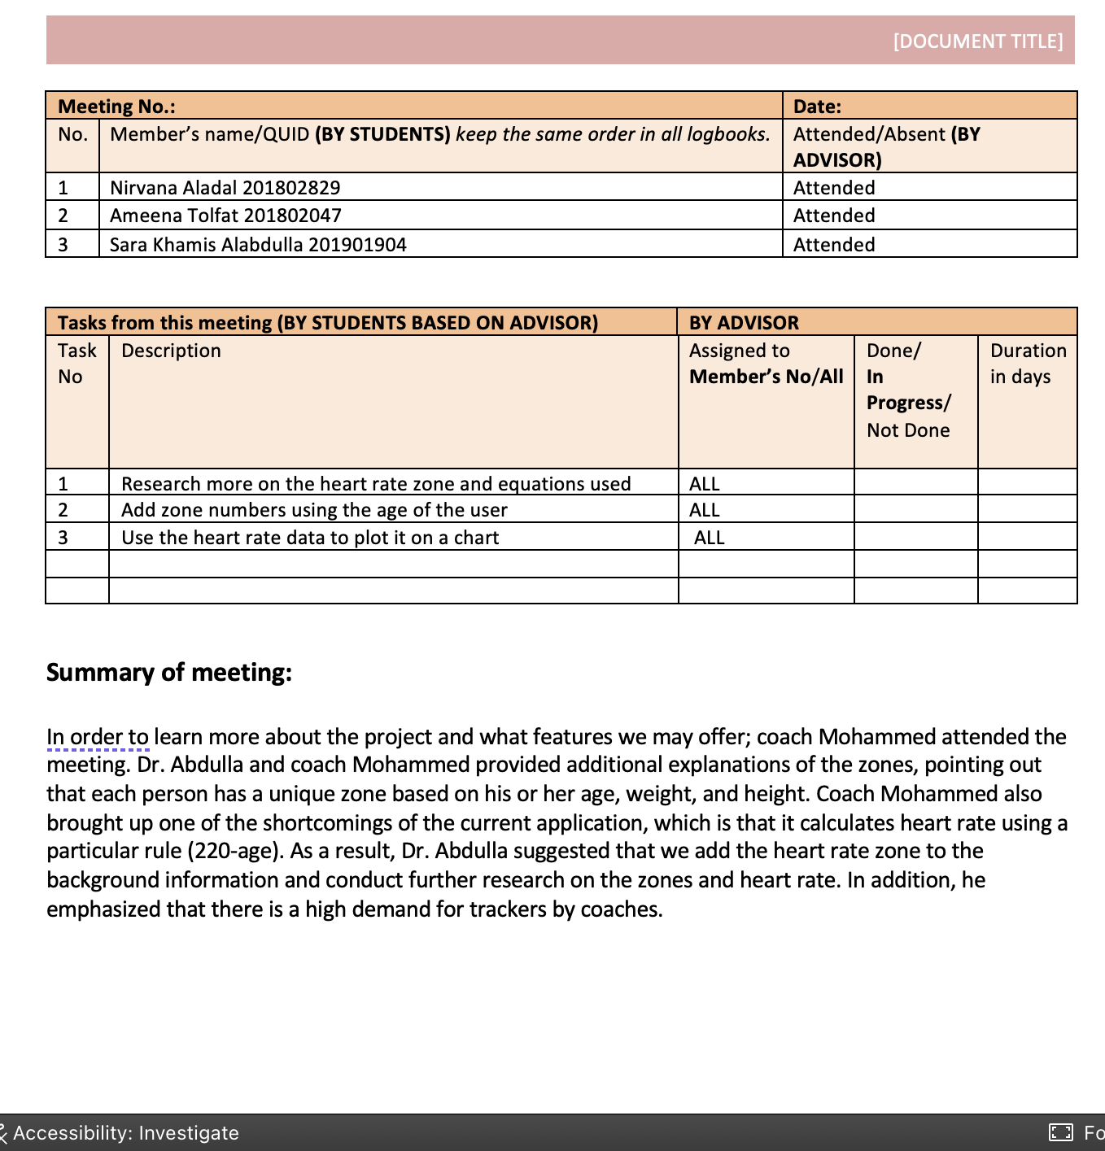

Figure . Meeting minutes

# Appendix D – Software Implementation

Table . Wireless connection code

|  |  |
| --- | --- |
| Description | Code |
| This code defines a class MainActivity which implements the OnMapReadyCallback and UdpReceiver.OnMessageReceivedListener interfaces. | public class MainActivity extends AppCompatActivity implements OnMapReadyCallback, UdpReceiver.OnMessageReceivedListener { |
| ARDUINO_IP is a String variable that holds the IP address of an Arduino device  ARDUINO_PORT is an int variable that holds the port number used to communicate with the Arduino device.  SERVER_IP is a String variable that holds the IP address of the computer running the Java program. The IP address 0.0.0.0 is a special value that indicates the program will listen for incoming connections on all available network interfaces.  SERVER_PORT is an int variable that holds the port number on which the Java program will listen for incoming connections. | private static final String *ARDUINO_IP* = "192.168.43.54"; private static final int *ARDUINO_PORT* = 8888;  private static final String *SERVER_IP* = "0.0.0.0";  private static final int *SERVER_PORT* = 8888; |
| This code starts the receiver on the IP address and port number specified by SERVER_IP and SERVER_PORT, respectively. The startReceiver method of UdpReceiver class creates a new thread to receive data over the UDP socket. | udpReceiver = new UdpReceiver(this); udpReceiver.startReceiver(*SERVER_IP*, *SERVER_PORT*); |
| The sendUdpMessage() method sends a UDP message to the IP address and port number of the arduino board. It creates a DatagramSocket object, converts the message to a byte array, creates an InetAddress object with the IP address of the target device, creates a DatagramPacket object with the message and target address/port, sends the packet through the socket, and then closes the socket. | private void sendUdpMessage(String message) {  try {  DatagramSocket socket = new DatagramSocket();  byte[] buf = message.getBytes();  InetAddress address = InetAddress.*getByName*(*ARDUINO_IP*);  DatagramPacket packet = new DatagramPacket(buf, buf.length, address, *ARDUINO_PORT*);  socket.send(packet);  socket.close();  } catch (IOException e) {  e.printStackTrace();  } } |
| In the UDPReceiver class  The startReceiver method in UdpReceiver class creates a new DatagramSocket object to receive incoming UDP packets on a specified server IP address and port number. It then starts a new thread to listen for incoming packets by calling the receive method of the DatagramSocket class. Once a packet is received, the data is extracted and converted to a string using UTF-8 encoding. | public void startReceiver(String serverIp, int serverPort) {  socket = new DatagramSocket(serverPort, InetAddress.*getByName*(serverIp));  isRunning = true;  start();  } |
| In the UDPReceiver class  run(): This method is executed when the thread starts, and it constantly listens for incoming data. When data is received, it creates a DatagramPacket object, extracts the message from it, and calls the onMessageReceived() method that passes the message as a string argument. | public void run() {  byte[] buffer = new byte[*BUFFER_SIZE*];  DatagramPacket packet = new DatagramPacket(buffer, *BUFFER_SIZE*);  while (isRunning) {  try {  socket.receive(packet);  String message = new String(packet.getData(), 0, packet.getLength(), StandardCharsets.*UTF_8*); listener.onMessageReceived(message);  } } |
| The connection and communication are established by importing two Arduino IDE libraries into this code.  The microcontroller is able to connect to the network via the Wifi.h. While WiFiUdp allows the transmission and reception of packets using the UPD protocol | #include <WiFi.h>  #include <WiFiUdp.h> |
| WiFiUDP Udp; generates a WiFiUDP class instance and assigns it to the Udp object. Over a Wi-Fi network, this object will be used to transmit and receive UDP packets.  A new instance of the IPAddress class is created and assigned to the variable udpServerIP by the line of IPAddress udpServerIP(172, 20, 10, 3). The UDP server's IP address, with which the board will communicate, is set using it.  Unsigned integer variable udpServerPort is created and given the value 8888 by the statement unsigned int udpServerPort =. The UDP server's port number, which the board will use for communication, is specified by this. | const char* ssid = "HUAWEI MatePad Pro";  const char* password = "123456789";  WiFiUDP Udp;  IPAddress udpServerIP(172, 20, 10, 3);  unsigned int udpServerPort = 8888; |
| The serial monitor in the Arduino IDE is used by this code to print messages to the user.  Using the network name (ssid) specified by the user, the code initially prints a message indicating that it is attempting to connect to the Wi-Fi network.  The Wi-Fi connection is then established using the supplied ssid and password by calling the WiFi.begin() function.  The Wi-Fi connection is repeatedly checked using a while loop, and the loop keeps running until the connection is established successfully. A message indicating that the connection operation is still in progress is printed to the serial monitor during this time. | Serial.print("Connecting to ");  Serial.println(ssid);  WiFi.begin(ssid, password);  while (WiFi.status() != WL_CONNECTED) {  delay(1000);  Serial.println("Connecting to WiFi...");  }  Serial.println("Connected to WiFi"); |
| This code configures the board's UDP communication port, which enables quick and effective network connectivity.  The port to utilize for communication is specified by the udpServerPort variable. The microcontroller can send and receive UDP packets after the Udp.begin() function is used to initialize the UDP port. | Udp.begin(udpServerPort);  Serial.print("Listening for UDP packets on port: ");  Serial.println(udpServerPort); |

Table . Sensors Data code

|  |  |
| --- | --- |
| Description | Code |
| These are the libraries that we utilized in order to read the sensors data and make use of their functions. | #include <Wire.h>  #include "MAX30105.h"  #include "heartRate.h"  #include <Adafruit_MPU6050.h>  #include <Adafruit_Sensor.h>  #include <Adafruit_GPS.h> |
| The code defines a variable that will be transmitted in a packet to the application. The variable will contain data that is collected by the sensors using the board. | beatsPerMinute = 60 / (delta / 1000.0);  beatAvg /= RATE_SIZE;  long time = currentTime - startTime;  float accelx = a.acceleration.x; float accely = a.acceleration.y; float accelz = a.acceleration.z; float gyrox = g.gyro.x; float gyroy = g.gyro.y; float gyroz = g.gyro.z;  ",Latitude=" + String(GPS.latitude, 4); ",Longitude=" + String(GPS.longitude, 4); |
| If the value falls inside a particular range, this code will compute the beats per minute .To give a more accurate reading, it then calculates the average BPM over a period of time. | if (checkForBeat(irValue) == true)    {      //We sensed a beat!      long delta = millis() - lastBeat;      lastBeat = millis();      beatsPerMinute = 60 / (delta / 1000.0);      if (beatsPerMinute < 255 && beatsPerMinute > 20)      {        rates[rateSpot++] = (byte)beatsPerMinute; //Store this reading in the array        rateSpot %= RATE_SIZE; //Wrap variable        //Take average of readings        beatAvg = 0;        for (byte x = 0 ; x < RATE_SIZE ; x++)          beatAvg += rates[x];        beatAvg /= RATE_SIZE;      }    } |

Table . Send and receive data code

|  |  |
| --- | --- |
| When a message is received, the onMessageReceived function in Android Studio is called.  It divides a text into substrings by using "," as the delimiter and puts the results in an array named "data," assuming the string includes the delimiter. | public void onMessageReceived(String message) {  String[] data = message.split(",");    if (message.contains(",")) {  data = message.split(",");  } |
| The array is then iterated through, examining each substring to verify if it begins with a specified prefix, such as "IR=" or "BPM=". If it does, it extracts the value after the prefix and stores it in a variable. The latitude and longitude values are converted to decimal degrees from a specified format. Finally, the retrieved values are updated in the UI. | for (String item : data) {  if (item.startsWith("IR=")) {  irValue = Integer.*parseInt*(item.substring(3));  } else if (item.startsWith("BPM=")) {  beatsPerMinute = Float.*parseFloat*(item.substring(4));  if (beatsPerMinute >= 60 && beatsPerMinute <= 100) {  addEntry(beatsPerMinute);  }  } else if (item.startsWith("Avg BPM=")) {  beatAvg = Integer.*parseInt*(item.substring(8));  } else if (item.startsWith("Time=")) {  milliseconds = Long.*parseLong*(item.substring(5));  } else if (item.startsWith("AccelX=")) {  accelx = Float.*parseFloat*(item.substring(7));  } else if (item.startsWith("AccelY=")) {  accely = Float.*parseFloat*(item.substring(7));  } else if (item.startsWith("AccelZ=")) {  accelz = Float.*parseFloat*(item.substring(7));  } else if (item.startsWith("GyroX=")) {  gyrox = Float.*parseFloat*(item.substring(6));  } else if (item.startsWith("GyroY=")) {  gyroy = Float.*parseFloat*(item.substring(6));  } else if (item.startsWith("GyroZ=")) {  gyroz = Float.*parseFloat*(item.substring(6));  } else if (item.startsWith("Latitude=")) {  // Convert latitude from DDMM.MMMM to decimal degrees  float ddmm = Float.*parseFloat*(item.substring(9));  float degrees = (float) Math.*floor*(ddmm / 100.0f);  float minutes = ddmm - degrees * 100.0f;  latitude = degrees + minutes / 60.0f;  } else if (item.startsWith("Longitude=")) {  // Convert longitude from DDDMM.MMMM to decimal degrees  float dddmm = Float.*parseFloat*(item.substring(10));  float degrees = (float) Math.*floor*(dddmm / 100.0f);  float minutes = dddmm - degrees * 100.0f;  longitude = degrees + minutes / 60.0f;  } |
| These methods generate three click listeners for three separate buttons, each of which is paired with a different music. When a button is pressed, the matching number is transmitted as a UDP message using the "sendUdpMessage" method. The numbers are used to initiate the playing of various tunes. | buttonPlayMelody1.setOnClickListener(new View.OnClickListener() {  @Override  public void onClick(View v) {  sendUdpMessage("1");  } });  buttonPlayMelody2.setOnClickListener(new View.OnClickListener() {  @Override  public void onClick(View v) {  sendUdpMessage("2");  } });  buttonPlayMelody3.setOnClickListener(new View.OnClickListener() {  @Override  public void onClick(View v) {  sendUdpMessage("3");  } }); |

Table . Gui implementation code

|  |  |
| --- | --- |
| In the onMessageReceived function, The setText() function is used to update the messageTextView object with a formatted string containing three lines of heart rate information retrieved from the HR sensor. The current beats per minute, the heart rate zone determined by the getHeartRateZone() function, and the average beats per minute are included in these lines.  The getHeartRateZone()method determines the heart rate zone based on the current beats per minute and user age. It returns "N/A" if the age is unknown. It determines the percentage of the maximum heart rate that the current bpm represents by utilizing the calculateMaxHeartRate() function to calculate the maximum heart rate. The algorithm yields one of the five heart rate zones based on this percentage: warm-up, fat burn, cardio, peak, and max. | messageTextView.setText(  "\nBeats Per Minute: " + finalBeatsPerMinute +  "\nHeart Rate Zone: " + getHeartRateZone(finalBeatsPerMinute) +  "\nAverage Beats Per Minute: " + finalBeatAvg );  private String getHeartRateZone(float bpm) {  if (userAge == 0) {  return "N/A";  }   int maxHeartRate = calculateMaxHeartRate(userAge);  float percentageOfMax = bpm / maxHeartRate;   if (percentageOfMax < 0.6) {  return "Zone 1 (Warm-up)";  } else if (percentageOfMax < 0.7) {  return "Zone 2 (Fat burn)";  } else if (percentageOfMax < 0.8) {  return "Zone 3 (Cardio)";  } else if (percentageOfMax < 0.9) {  return "Zone 4 (Peak)";  } else {  return "Zone 5 (Max)";  } } |
| In the onMessageReceived function, this code generates a line chart with newly collected information by retrieving an existing data collection and adding a new entry to it. The chart view is then refreshed and repositioned to provide the most recent data.  This code generates and provides a LineDataSet object for displaying heart rate data on a line chart. During startup, the LineDataSet object's attributes such as label, line width, color, and chart mode are set. The cubic intensity is likewise adjusted to 0.2f by the approach. This object is then used to generate the LineData object that appears on the chart.  The addEntry function updates the chart with a new heart rate data entry. If the chart data is not null, it retrieves the data set with index 0. If no data set exists, it generates one using createSet() and adds it to the chart data. It then creates a new data set entry with the current heart rate value, changes the chart data, and alerts the chart of the change. It reduces the number of visible entries and switches the chart view to the most recent item. | // Add the new data to the chart LineData chartData = chart.getData();  if (chartData != null) {  ILineDataSet set = chartData.getDataSetByIndex(0);   if (set == null) {  set = createSet();  chartData.addDataSet(set);  }    chartData.addEntry(new Entry(set.getEntryCount(), finalBeatsPerMinute), 0);     chartData.notifyDataChanged();  chart.notifyDataSetChanged();   chart.moveViewToX(chartData.getEntryCount() - 1); }  private LineDataSet createSet() {   LineDataSet set = new LineDataSet(null, "BPM");  set.setAxisDependency(YAxis.AxisDependency.*LEFT*);  set.setLineWidth(3f);  set.setColor(Color.*WHITE*);  set.setHighlightEnabled(false);  set.setDrawValues(false);  set.setDrawCircles(false);  // set.setMode(LineDataSet.Mode.CUBIC_BEZIER);  set.setMode(LineDataSet.Mode.*LINEAR*);   set.setCubicIntensity(0.2f);  return set; }  private void addEntry(final float bpm) {  synchronized (chart.getData()) {   LineData data = chart.getData();   if (data != null) {   ILineDataSet set = data.getDataSetByIndex(0);   if (set == null) {  set = createSet();  data.addDataSet(set);  }   data.addEntry(new Entry(set.getEntryCount(), bpm), 0);  data.notifyDataChanged();    chart.notifyDataSetChanged(); chart.setVisibleXRangeMaximum(150);   chart.setVisibleXRangeMinimum(20);  chart.moveViewToX(data.getEntryCount());   }   }  } |
| This code prepares the MapView to display a map by collecting the API key from the layout file, setting the instance state, and calling a callback when the map is ready. The API key is generated by setting up the HMS Map Kit on App Gallery connect. | mMapView = findViewById(R.id.*mapView*); Bundle mapViewBundle = null; if (savedInstanceState != null) {  mapViewBundle = savedInstanceState.getBundle(*MAPVIEW_BUNDLE_KEY*); } MapsInitializer.*setApiKey*("DAEDAA28wtA5wCKUCYfQ5zui59S8joFuCE3kCYtMPOFLgu5cgnbqD3wSx2FIAuWUPMTc9GJFA4QYCN2YAsCHQiM8p52RL851agys/A=="); mMapView.onCreate(mapViewBundle); mMapView.getMapAsync(this); |
| When the map is ready to use, the OnMapReady function is called by the Huawei Map SDK. It begins by assigning the HuaweiMap object instance to a local variable named hMap. Then, using the latitude and longitude values supplied as arguments, it constructs a new latitude and longitude object. It generates a new MarkerOptions object and adds it to the map using hMap using this location.addMarker(). Finally, it uses hMap to relocate the camera to the desired point.The moveCamera() function places the camera on the LatLng coordinates. | @Override public void onMapReady(HuaweiMap map) {  Log.*d*(*TAG*, "onMapReady: ");  hMap = map;   LatLng location = new LatLng(latitude, longitude);    MarkerOptions markerOptions = new MarkerOptions().position(location);  hMap.addMarker(markerOptions);  hMap.moveCamera(CameraUpdateFactory.*newLatLngZoom*(location, 10f));  } |
| These two methods, askUserForAge() and askUserForName() create an dialog in order to ask the user for their name and age then displays the data on the EditText object. | private void askUserForAge() {  AlertDialog.Builder builder = new AlertDialog.Builder(this);  builder.setTitle("Enter your age");   final EditText input = new EditText(this);  input.setInputType(InputType.*TYPE_CLASS_NUMBER*);  builder.setView(input);   builder.setPositiveButton("OK", new DialogInterface.OnClickListener() {  @Override  public void onClick(DialogInterface dialog, int which) {  userAge = Integer.*parseInt*(input.getText().toString());  ageEditText.setText("Athlete Age: " + userAge);  }  });  builder.setNegativeButton("Cancel", new DialogInterface.OnClickListener() {  @Override  public void onClick(DialogInterface dialog, int which) {  dialog.cancel();  }  });   builder.show(); }  private void askUserForName() {  AlertDialog.Builder builder = new AlertDialog.Builder(this);  builder.setTitle("Enter your name");   final EditText input = new EditText(this);  builder.setView(input);   builder.setPositiveButton("OK", new DialogInterface.OnClickListener() {  @Override  public void onClick(DialogInterface dialog, int which) {  String userName = input.getText().toString();  nameEditText.setText("Athlete name: " + userName);  }  });  builder.setNegativeButton("Cancel", new DialogInterface.OnClickListener() {  @Override  public void onClick(DialogInterface dialog, int which) {  dialog.cancel();  }  });   builder.show(); } |